|  |  |
| --- | --- |
| Name | Sanjyot Satvi |
| Course Number | CPSC 449 |
| Semester | Fall 2023 |
| Exercise | 1 |
| Section | 1 |

Setting Up the Environment :

**1.Obtaining Chinook Db and extracting it**

**wget https://www.sqlitetutorial.net/wp-content/uploads/2018/03/chinook.zip**

**unzip chinook.zip**

**Output -**

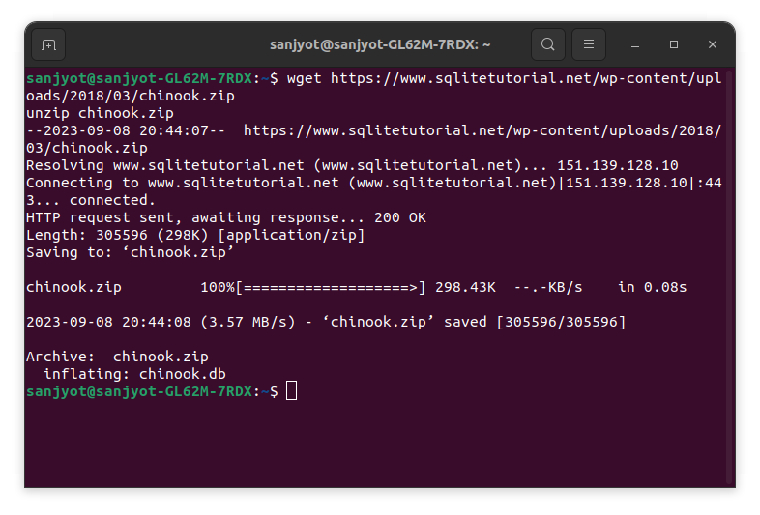**Fig 1.Output**

**2.Installing sqlite3 command line tool then dumping the database**

**sudo apt update**

**sudo apt install --yes sqlite3**

**sqlite3 chinook.db .dump**

**Output -**

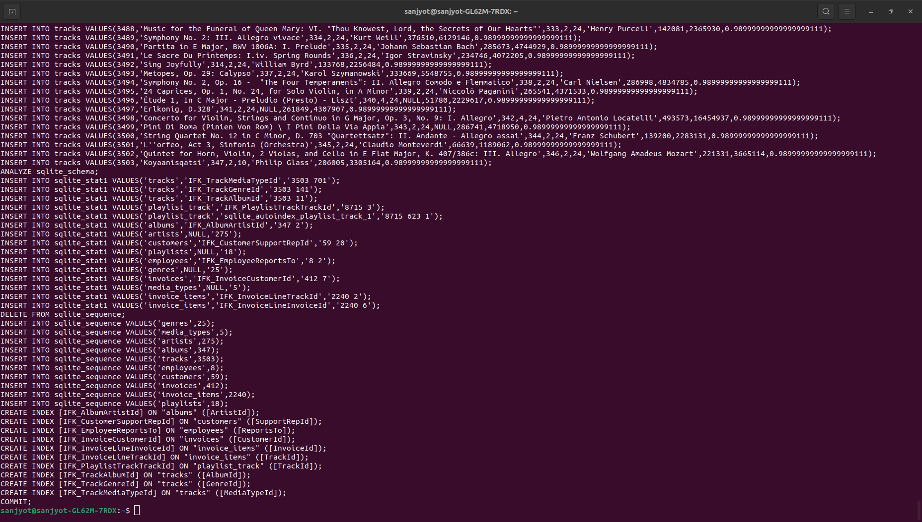 **Fig.2 Output after dumping db**

As per Fig.2 We successfully obtained the chinook.db and verified by dumping the database

**3.Installing pip and venv packages**

**sudo apt install --yes python3-pip python3-venv**

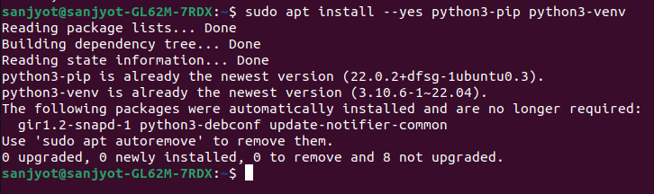**Fig 3.The packages were already installed successfully**

**4.Creating a Virtual Environment**

We will create a virtual environment where all the packages required will be installed .

Commands to create virtual environment and activating the same

**python3.10 -m venv $HOME/.venv**

**echo 'source $HOME/.venv/bin/activate' | tee -a $HOME/.bashrc**

**. $HOME/.venv/bin/activate**

**5. Installing n version manager for Node js**

Use n-install to install the n version manager for Node.js , we reload the bash shell config and update the latest version of the Npm package manager

commands -

**curl -s -L http://git.io/n-install | bash -s -- -y**

**. $HOME/.bashrc**

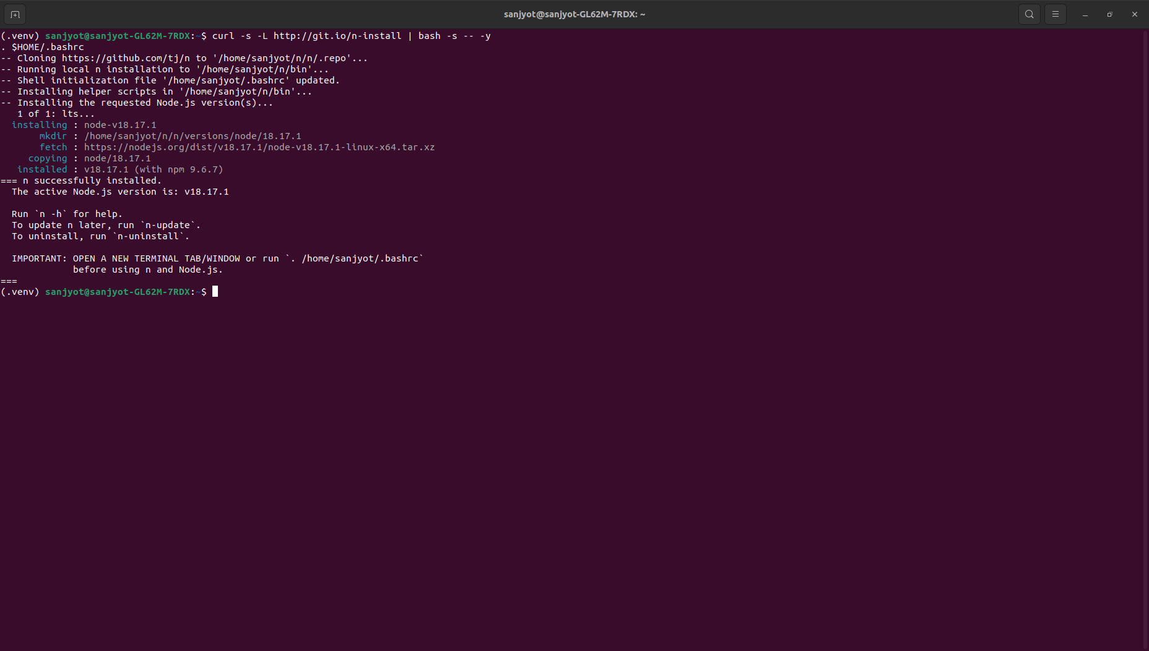**Fig 4.Output for Step 4**

**5.Installing Soul Server to expose REST API for our chinook Database**

commands -

**npm install --global soul-cli**

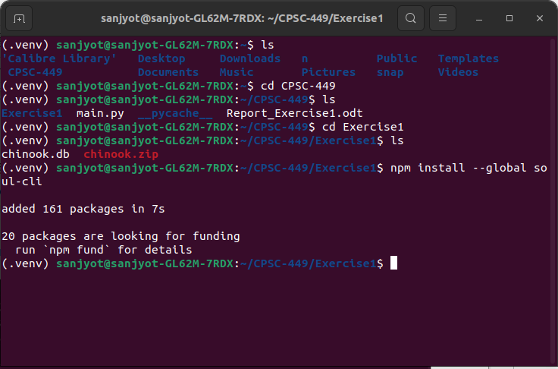**Fig 5. Installed Soul-cli globally**

command -

**npm update –global**

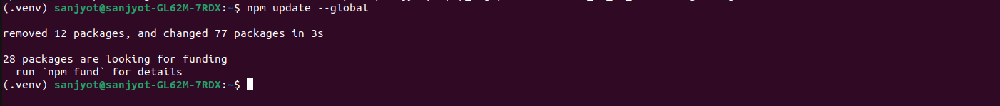**Fig 6. Output after updating packages**

**6.Install the** [**tuql**](https://github.com/bradleyboy/tuql) **server to expose a GraphQL API for an existing database.**

Commands -

**npm install --global tuql**

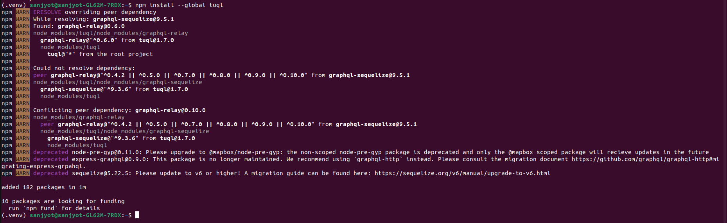**Fig 7. Installed tuql server to expose GraphQL API**

### **7.Start the API servers**

In separate terminal windows, start API servers for the chinook database

command -

**soul --database chinook.db --studio**

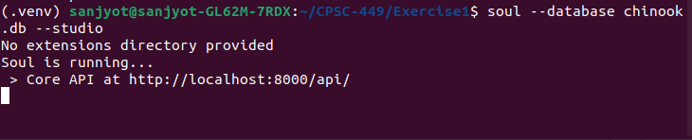**Fig 8. Soul Server is running Successfully at** **http://localhost:8000/api/**

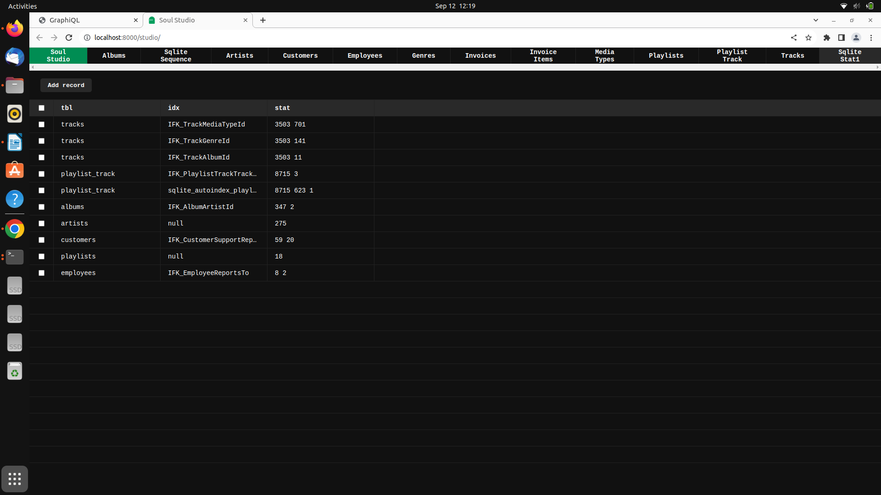**Fig 9. Soul Studio shows the database contents**

command-

**tuql --db chinook.db --graphiql**

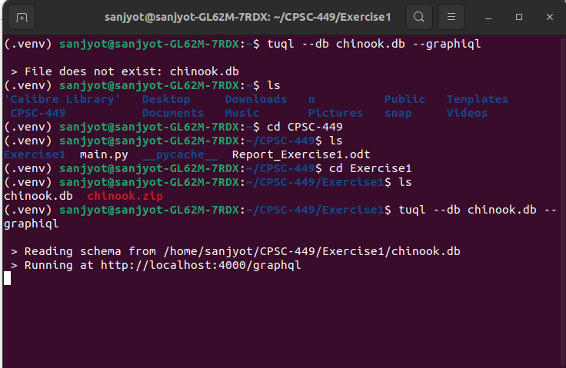**Fig 10. Tuql Server is running Successfully at** **http://localhost:4000/graphql/**

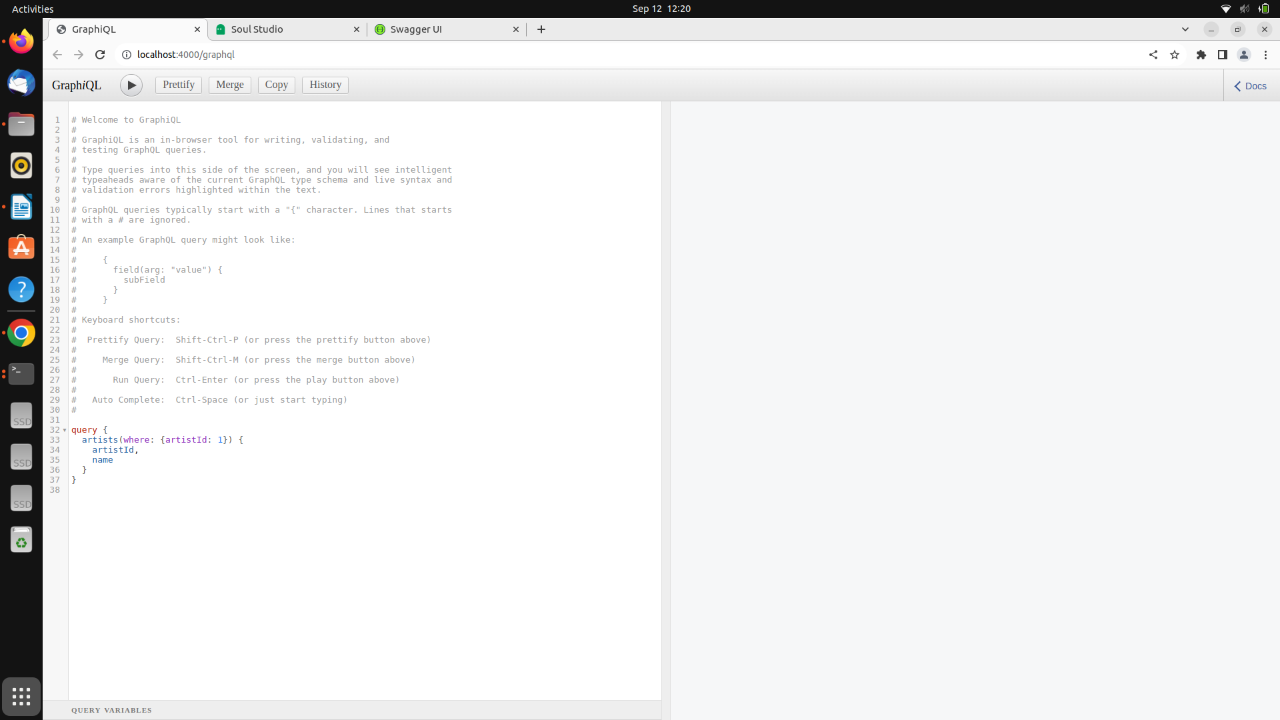**Fig 11. Output when accessing** [**http://localhost:4000/graphql/**](http://localhost:4000/graphql/)

## Querying data with REST and GraphQL

**8.Retrieve a record**

Visit the following URL to retrieve information about the first artist in the database using the REST API:

Endpoint

<http://localhost:8000/api/tables/artists/rows/1>

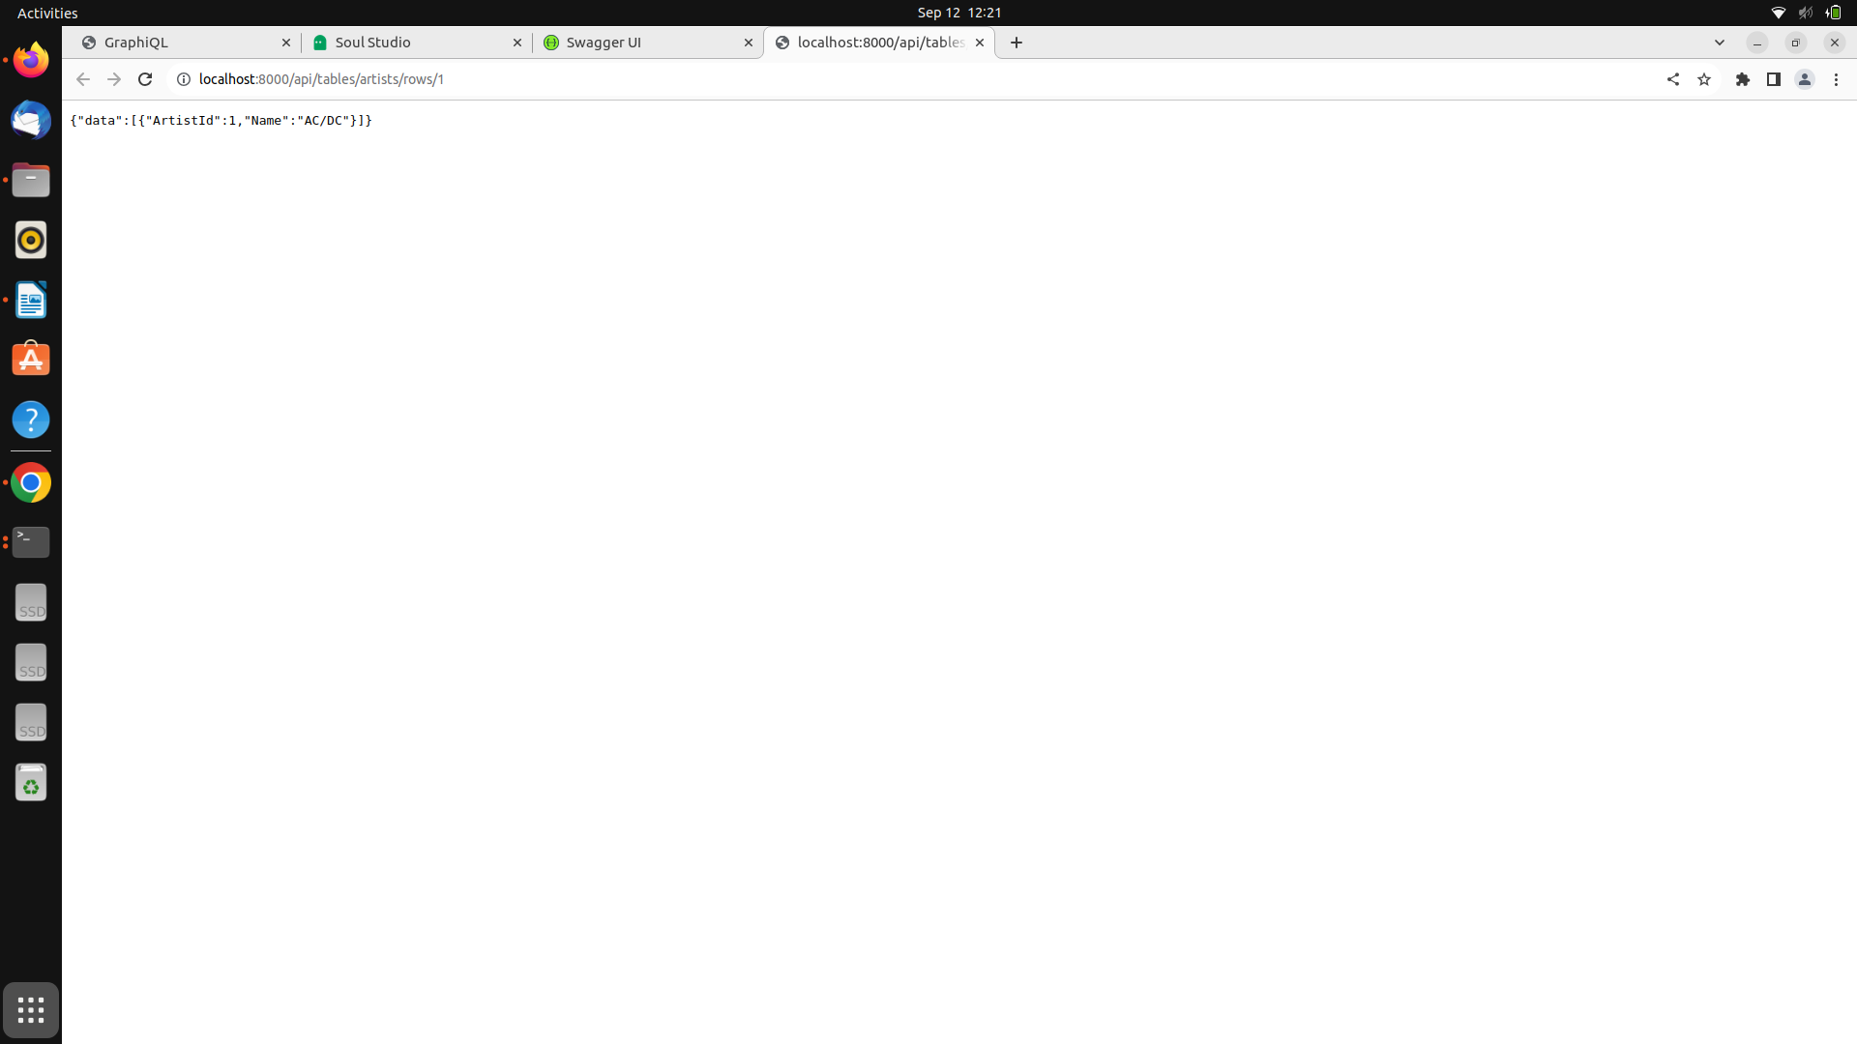**Fig 12. Output shows rows are retrieved through soul api**

In GraphiQL, execute the following query to retrieve the same information from the GraphQL API:

query {

artists(where: {artistId: 1}) {

artistId,

name

}

}

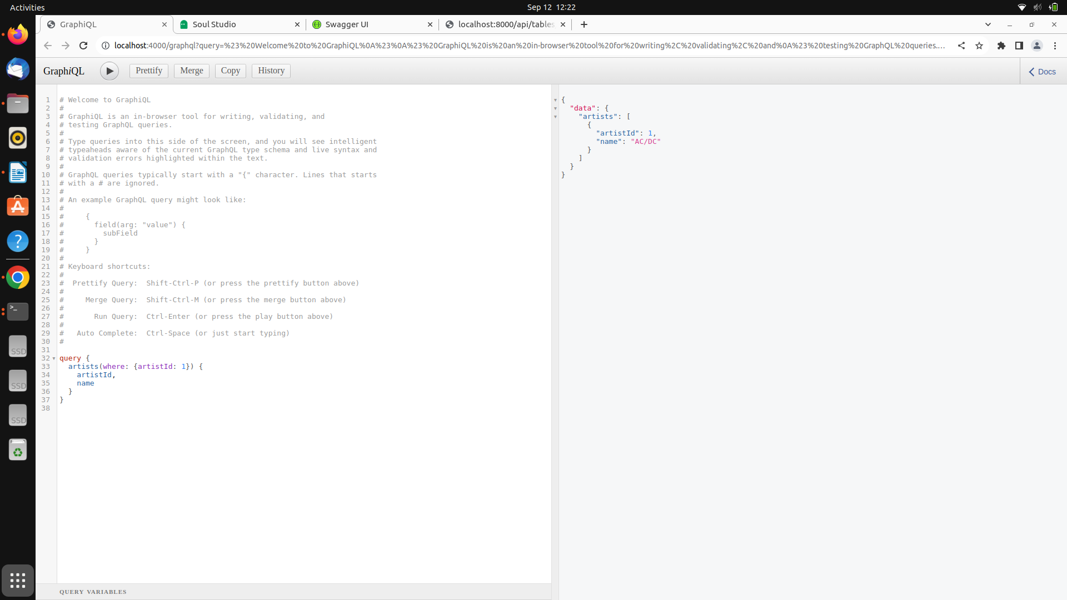**Fig 13. Successfully Ran Query in GraphiQL dashboard**

**9.Trying Complex Queries Using GraphQL**

a.Albums by the artist “Red Hot Chili Peppers.”

query getAlbumsByName {

artists(where: {Name: "Red Hot Chili Peppers"}) {

artistId

name

albums {

albumId

title

}

}

}  
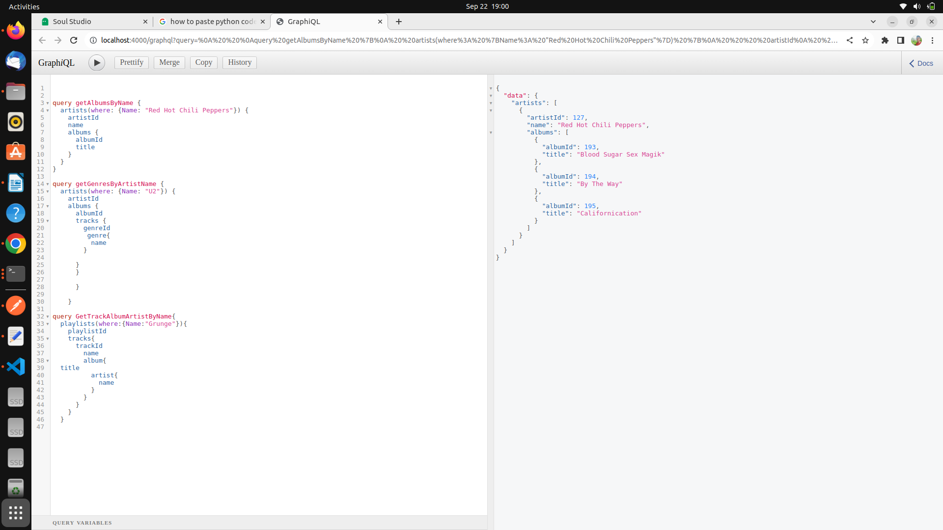

**Fig 14.Output for Query to retrive Albums by artists “Red Hot Chilli Peppers”**

2.Genres associated with the artist “U2.”

query getGenresByArtistName {

artists(where: {Name: "U2"}) {

artistId

albums {

albumId

tracks {

genreId

genre{

name

}

}

}

}

}  
  
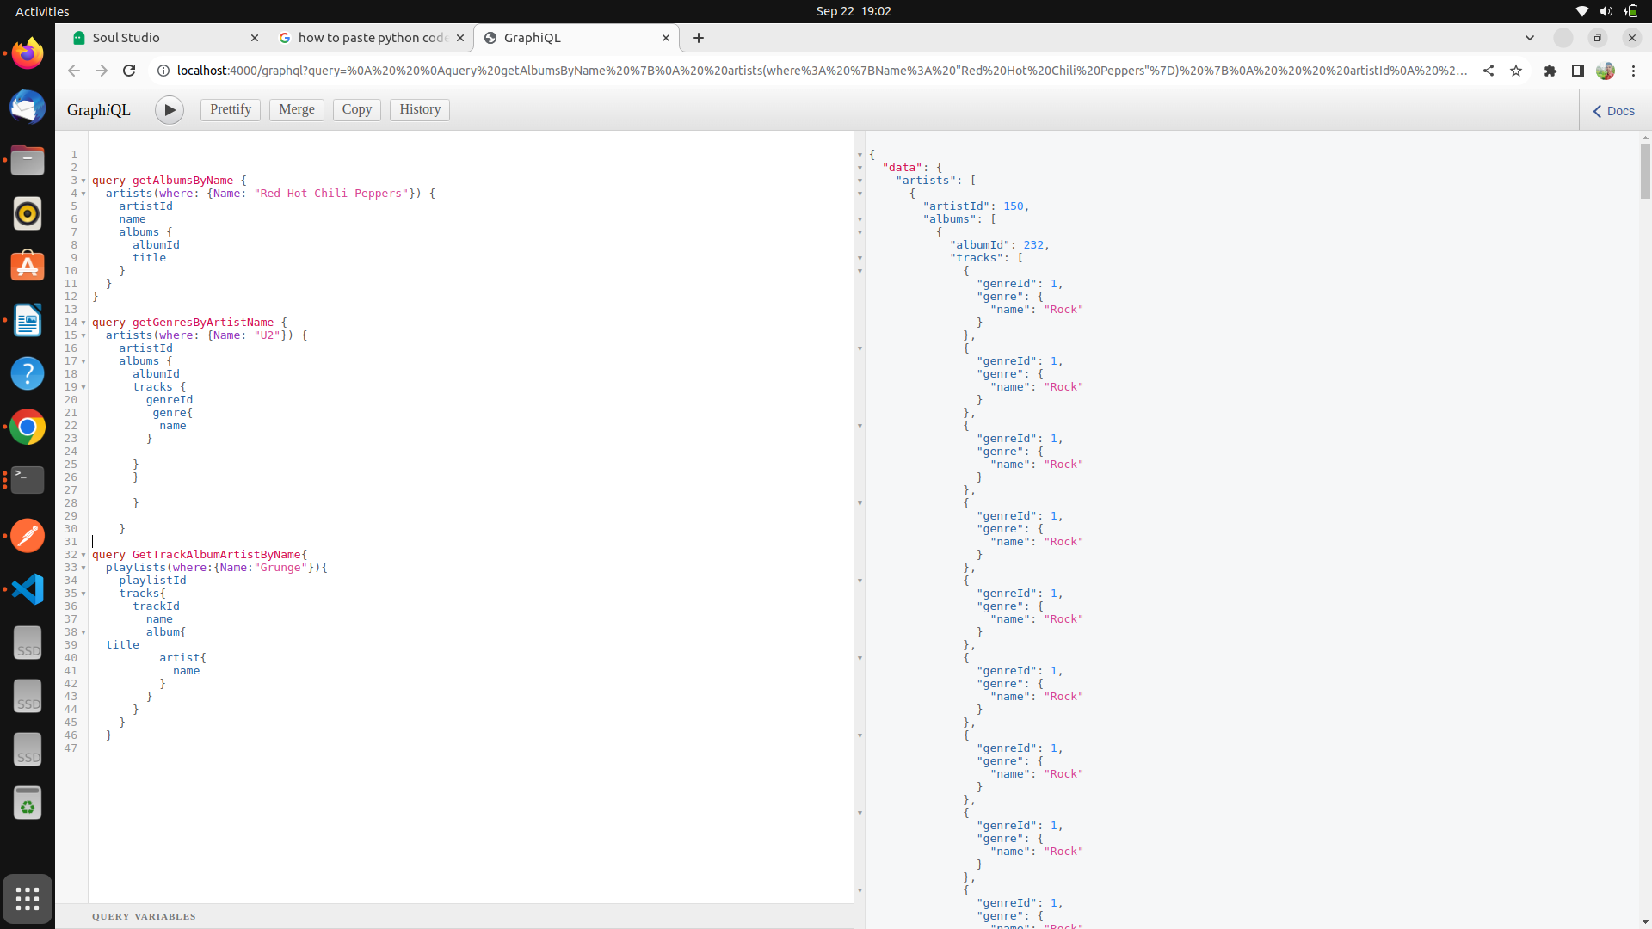

**Fig 15. Output for Query to Retrive Genres associated with the artist U2.**

3.Names of tracks on the playlist “Grunge” and their associated artists and albums.  
query {

playlists(where:{Name:"Grunge"}){

playlistId

tracks{

trackId

name

album{

title

artist{

name

}

}

}

}

}

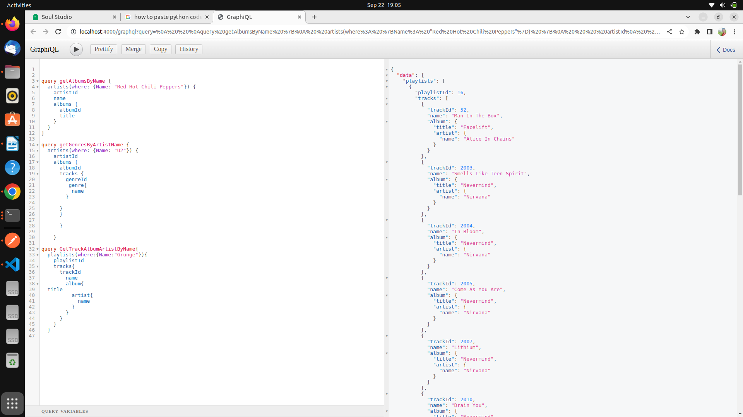

**Fig 16. Retrieved tracks on the playlist “Grunge” and their associated artists and albums.**

**10. Installing Requests Package to Make API calls for REST in python**

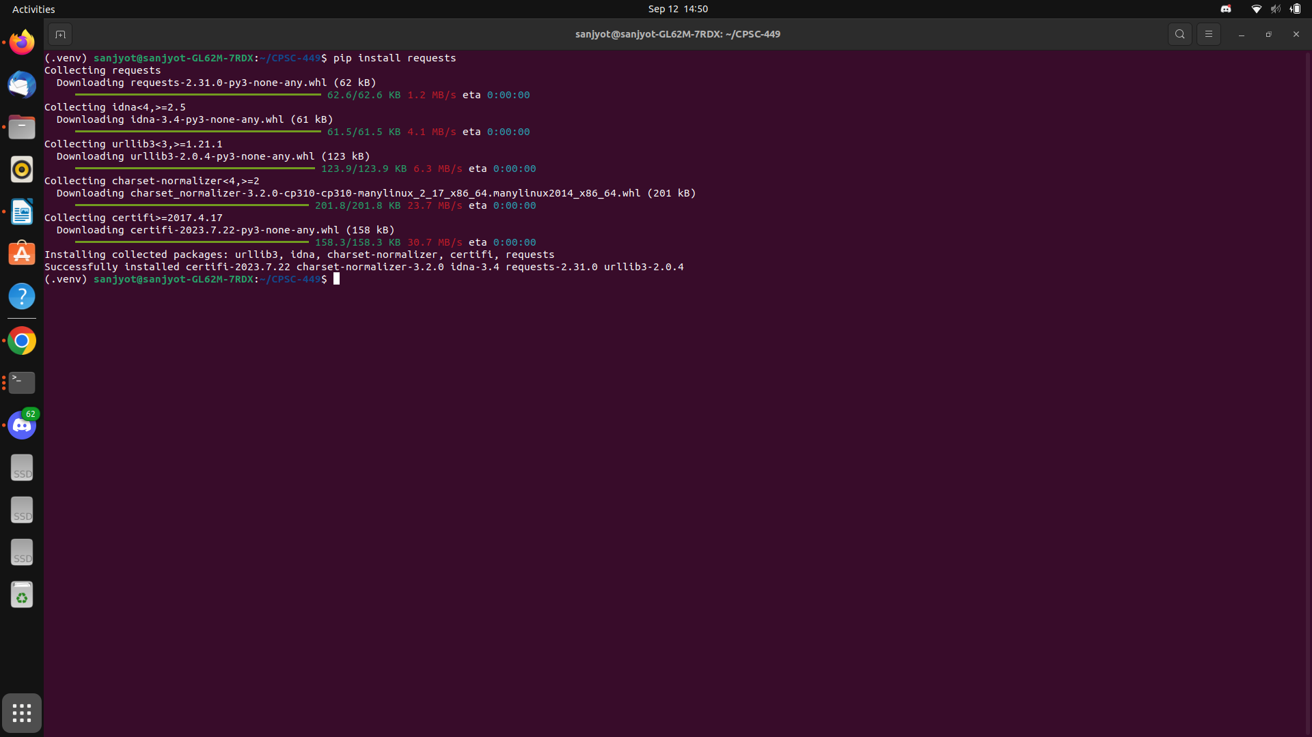**Fig 17. Successfully installed Requests Package**

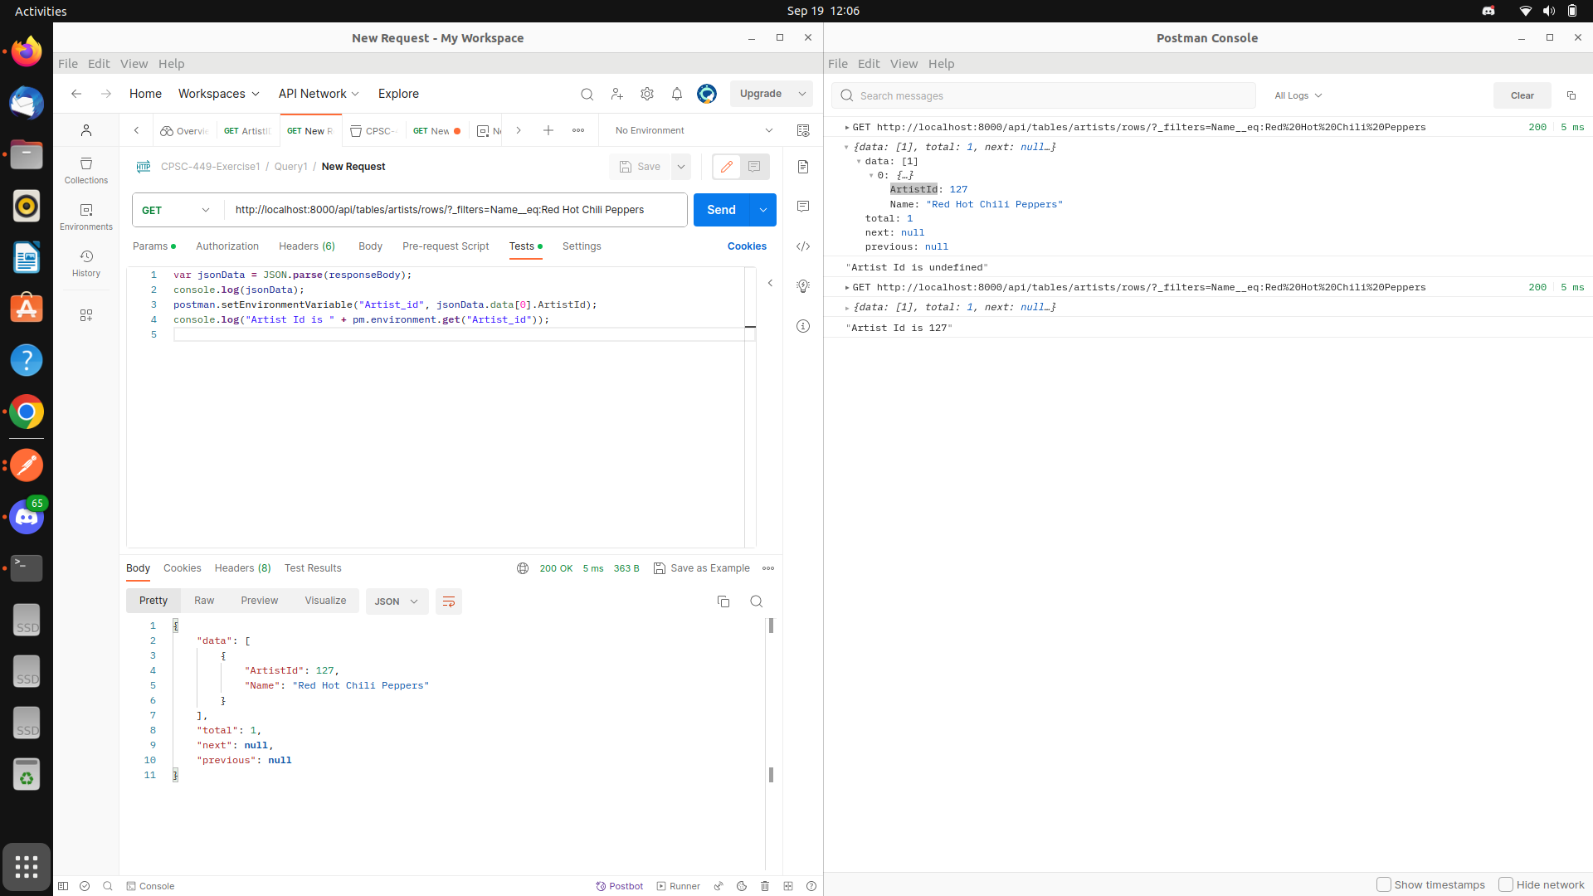  
  
  
  
Query 1 Completed Postman   
s

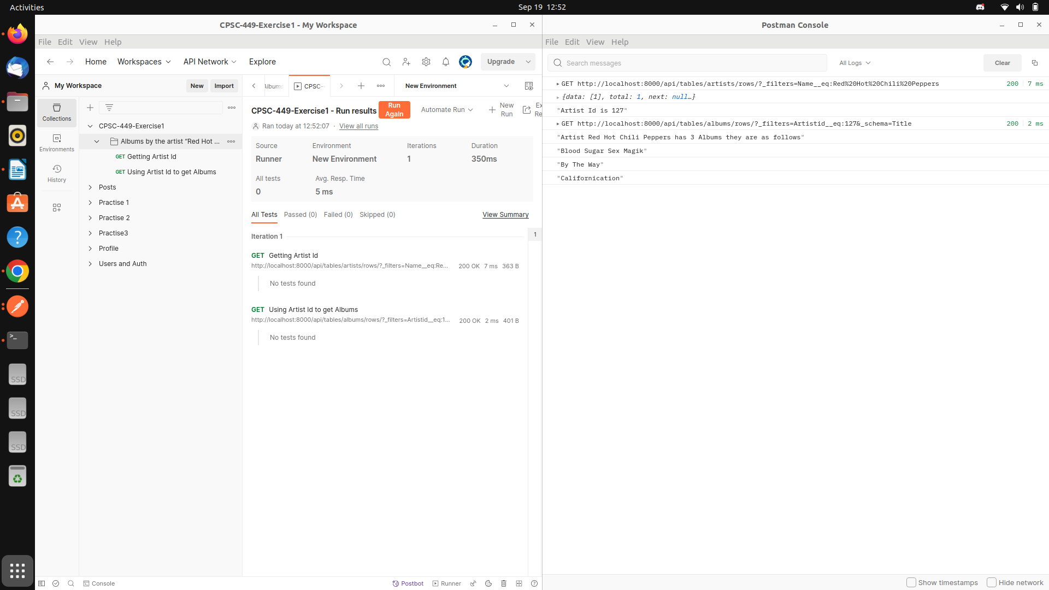

Query 2 postman – got bad request (need Pre -request script to pass single gener ID   
s

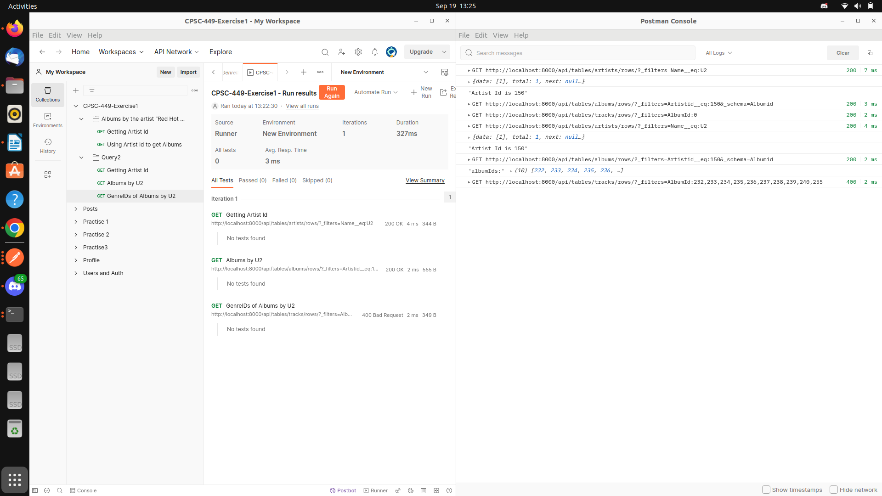  
  
  
Reference --- <https://www.postman.com/postman/workspace/postman-answers/request/9215231-3d9853fd-22d7-4f9e-8d4b-02cf8dc9c6e2>  
  
  
  
  
  
  
  
  
  
  
  
  
  
  
  
  
  
  
  
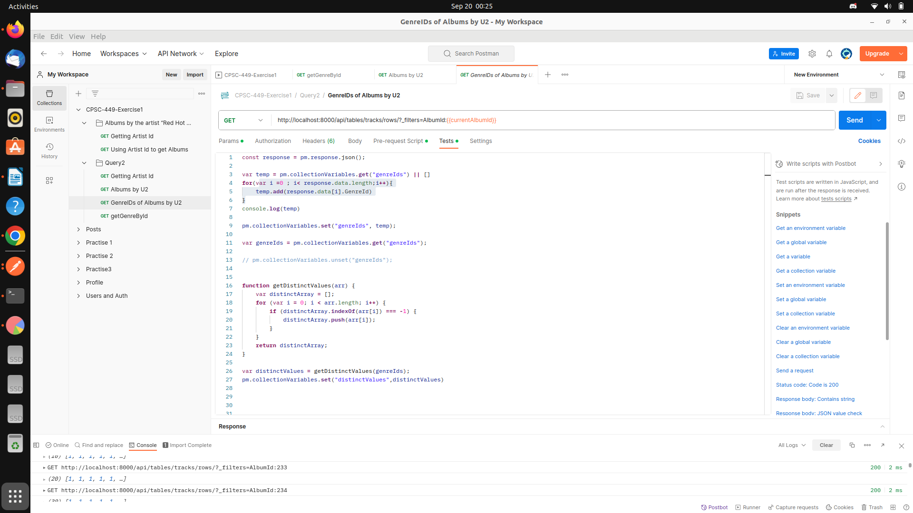

Added test script to get genre ids for all the albums and then wrote a function to get distinct genre Ids

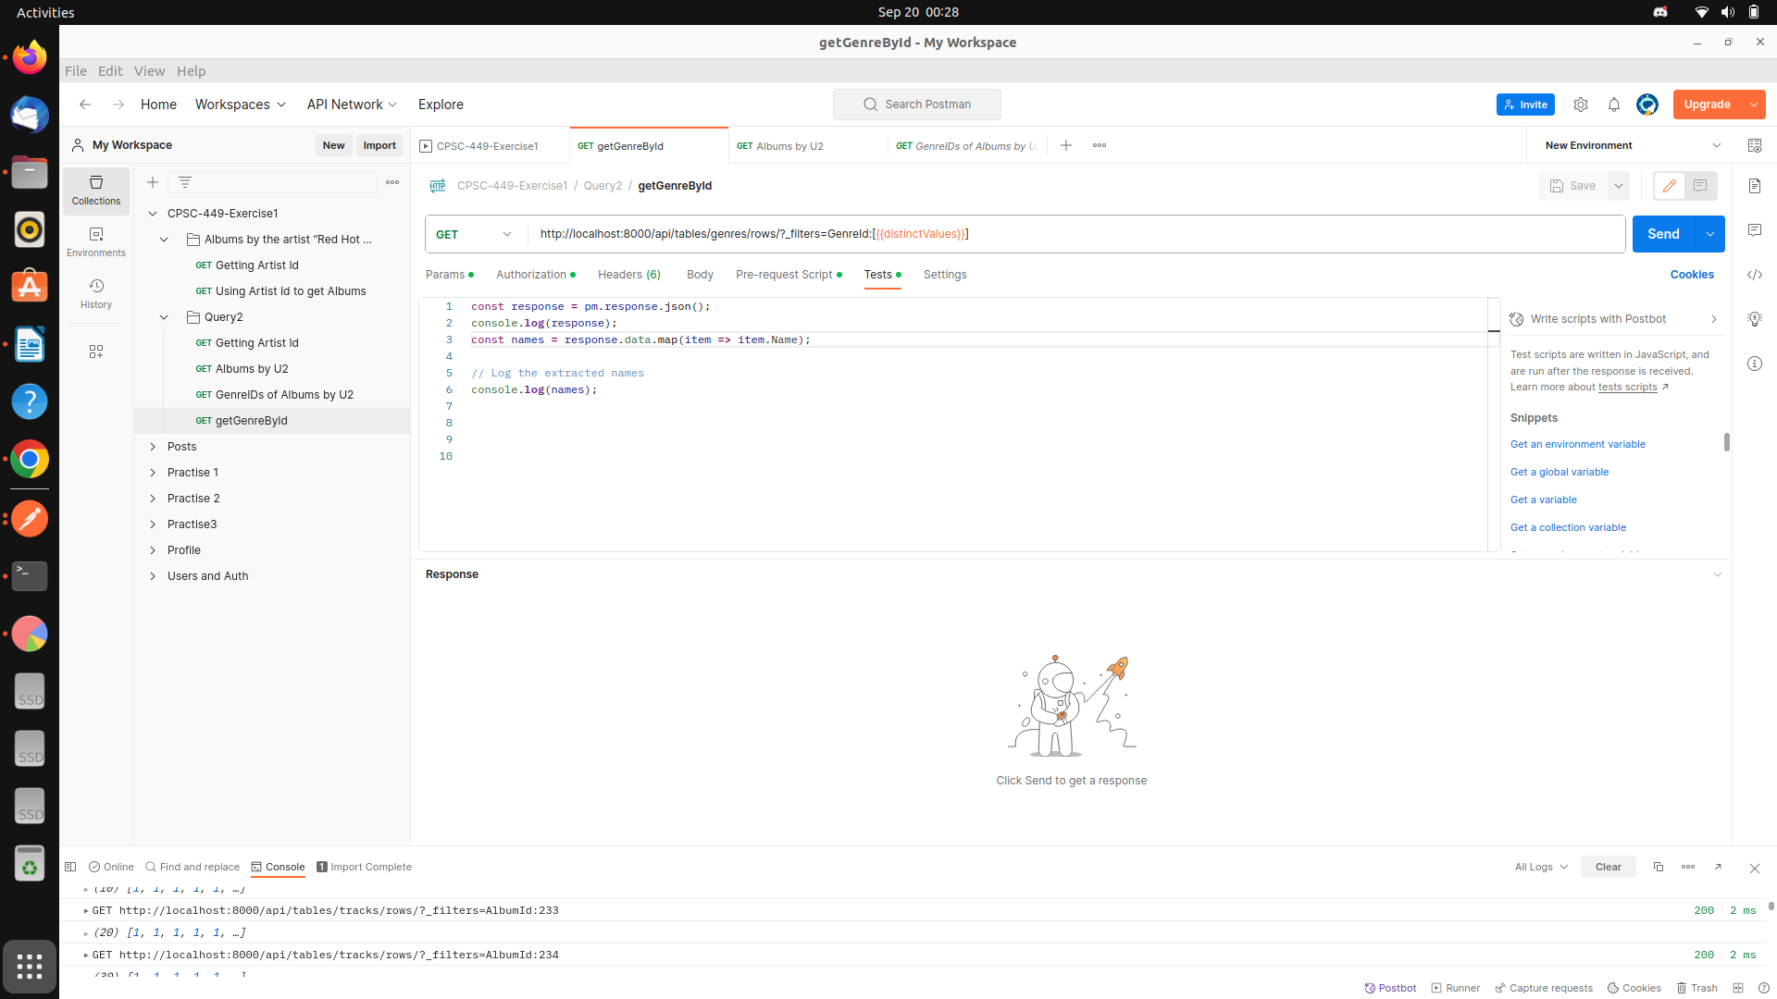

Added one more reest to get all the associated Genres based on the distinct genre ids

Query 3   
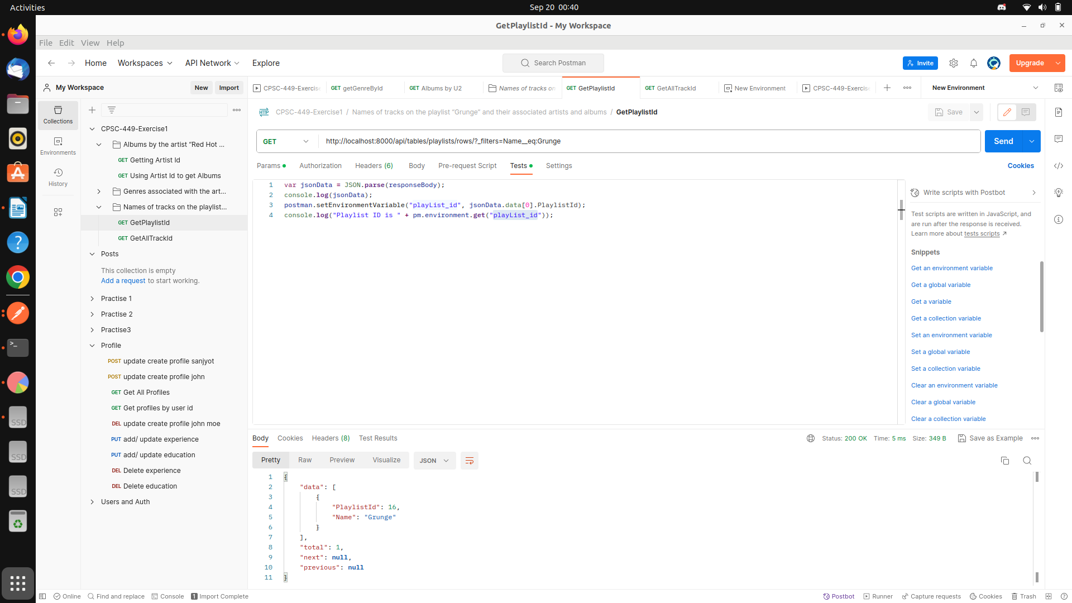

Getting playlists id of Grunge   
  
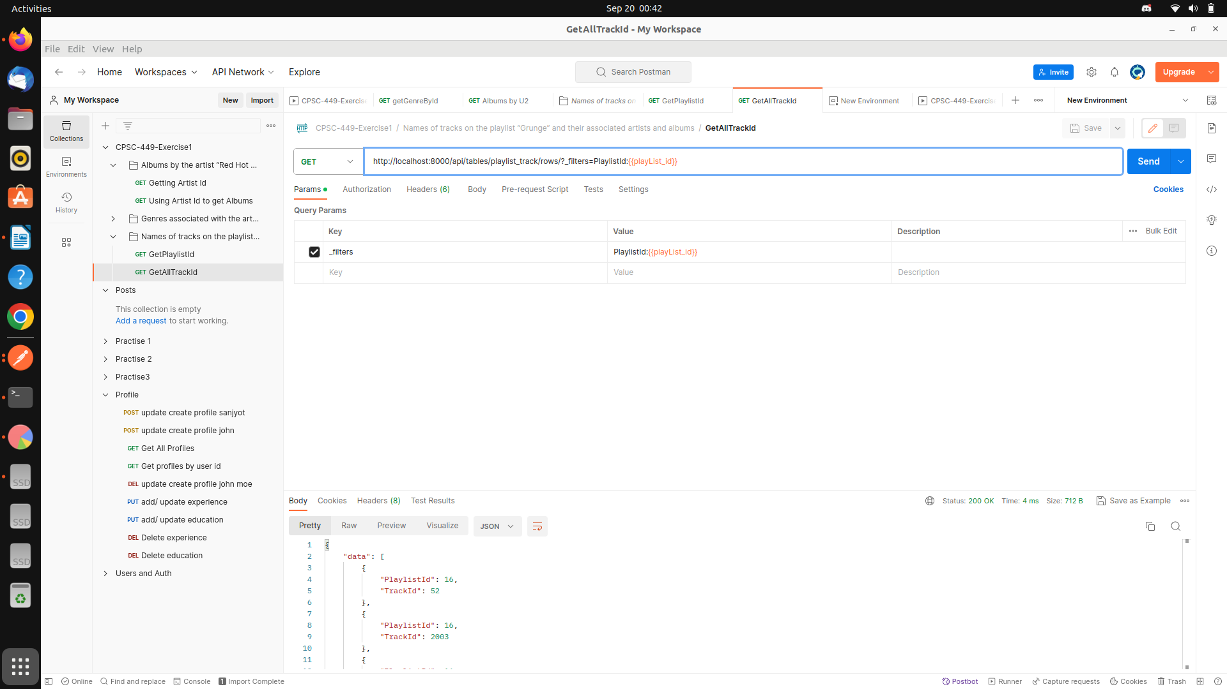  
Using playlist ID to get all Track ID associated with grunge   
  
  
  
  
{"data":[{"PlaylistId":16,"TrackId":52},{"PlaylistId":16,"TrackId":2003},{"PlaylistId":16,"TrackId":2004},{"PlaylistId":16,"TrackId":2005},{"PlaylistId":16,"TrackId":2007},{"PlaylistId":16,"TrackId":2010},{"PlaylistId":16,"TrackId":2013},{"PlaylistId":16,"TrackId":2194},{"PlaylistId":16,"TrackId":2195},{"PlaylistId":16,"TrackId":2198},{"PlaylistId":16,"TrackId":2206},{"PlaylistId":16,"TrackId":2512},{"PlaylistId":16,"TrackId":2516},{"PlaylistId":16,"TrackId":2550},{"PlaylistId":16,"TrackId":3367}],"total":15,"next":null,"previous":null}

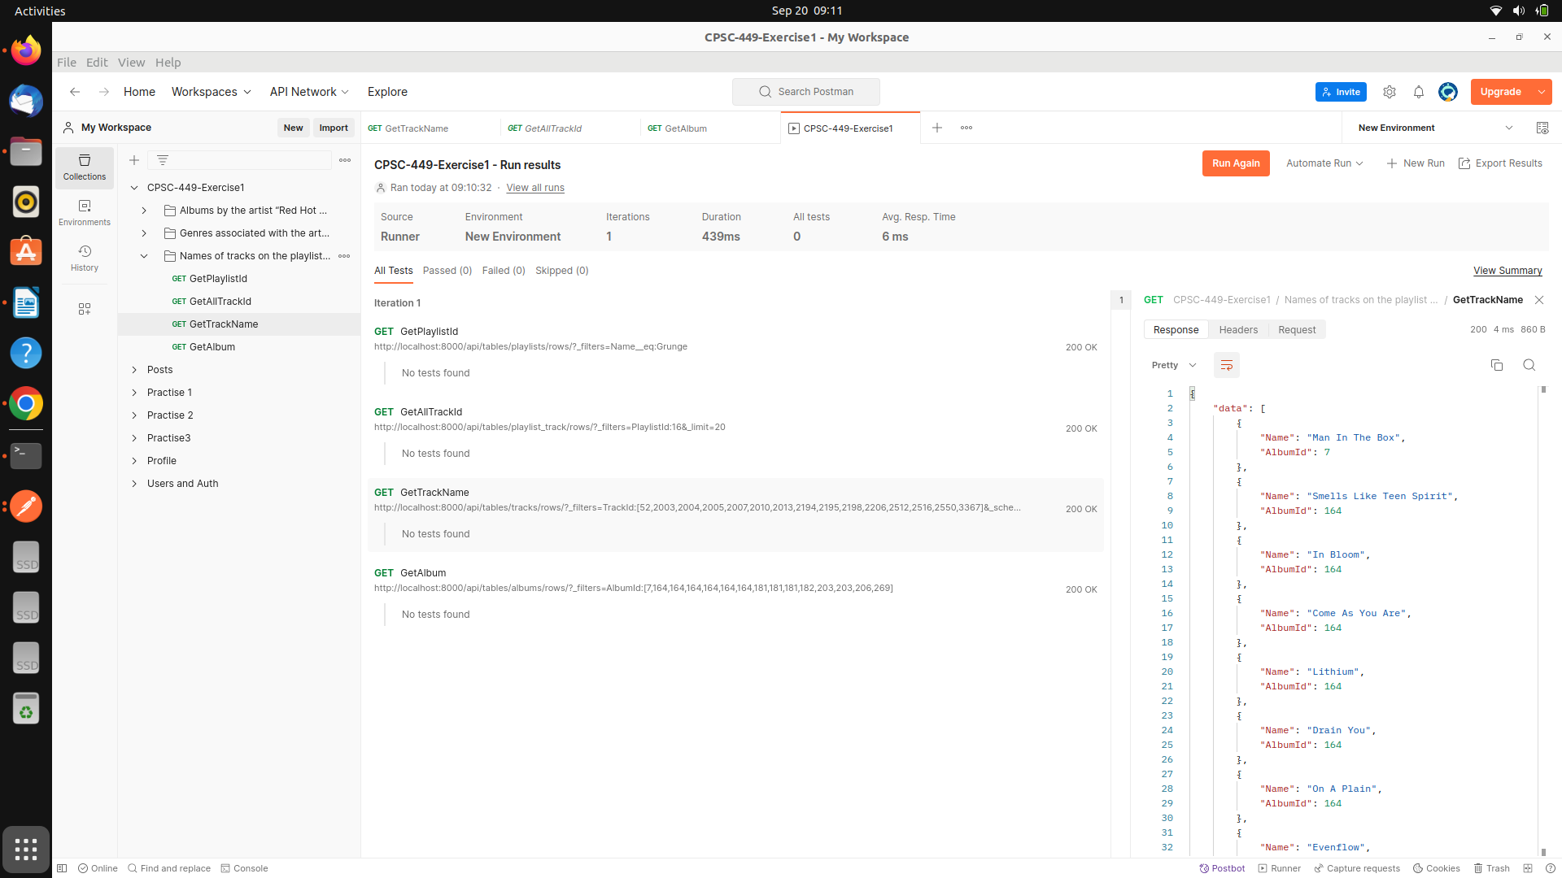  
  
based on all the track ids I am querying to get all associated album ids for that particular track id .   
<http://localhost:8000/api/tables/tracks/rows/?_filters=TrackId:[52,2003,2004,2005,2007,2010,2013,2194,2195,2198,2206,2512,2516,2550,3367]&_schema=Name,AlbumId&_limit=25>

Added schema to just get name and Album , limit search results to 25   
  
next -----

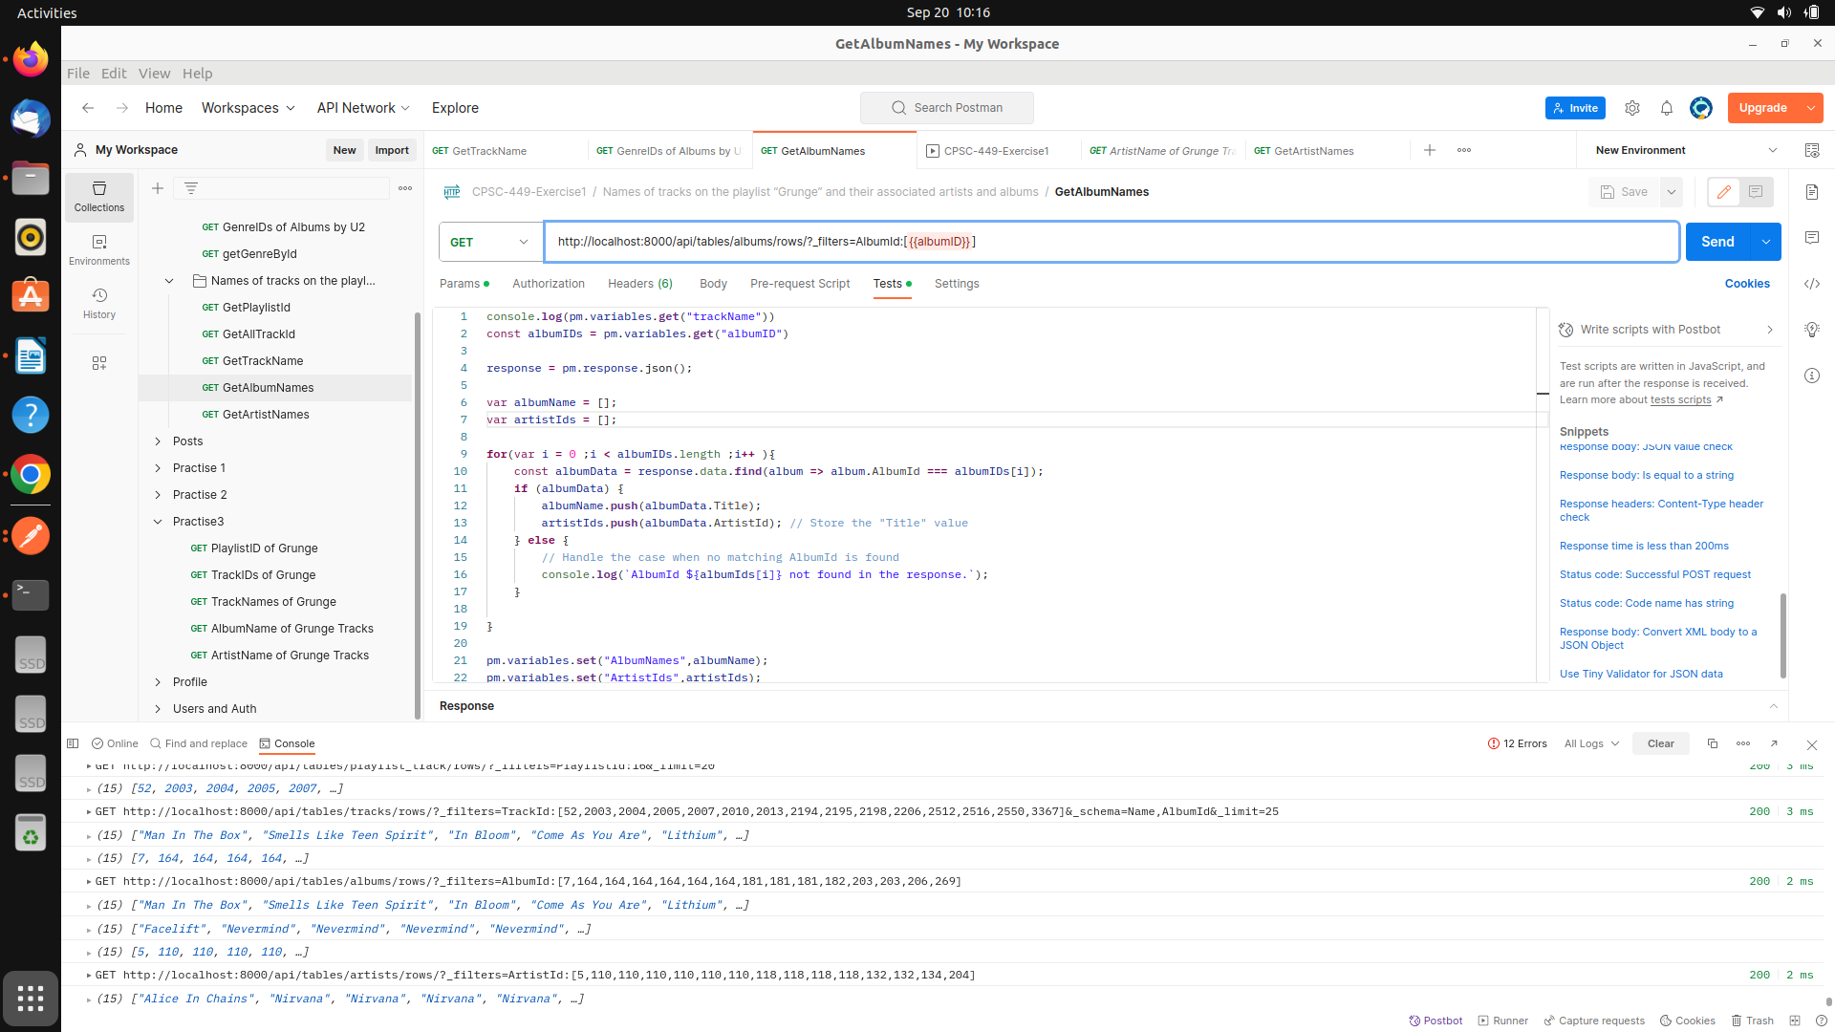  
  
Request -  
<http://localhost:8000/api/tables/albums/rows/?_filters=AlbumId:[7,164,164,164,164,164,164,181,181,181,182,203,203,206,269>]  
  
response -   
{"data":[{"AlbumId":7,"Title":"Facelift","ArtistId":5},{"AlbumId":164,"Title":"Nevermind","ArtistId":110},{"AlbumId":181,"Title":"Ten","ArtistId":118},{"AlbumId":182,"Title":"Vs.","ArtistId":118},{"AlbumId":203,"Title":"A-Sides","ArtistId":132},{"AlbumId":206,"Title":"Core","ArtistId":134},{"AlbumId":269,"Title":"Temple of the Dog","ArtistId":204}],"total":7,"next":null,"previous":null}  
  
wrote test script to match Title for each of the Albums ( handling one to many relations )   
  
ss

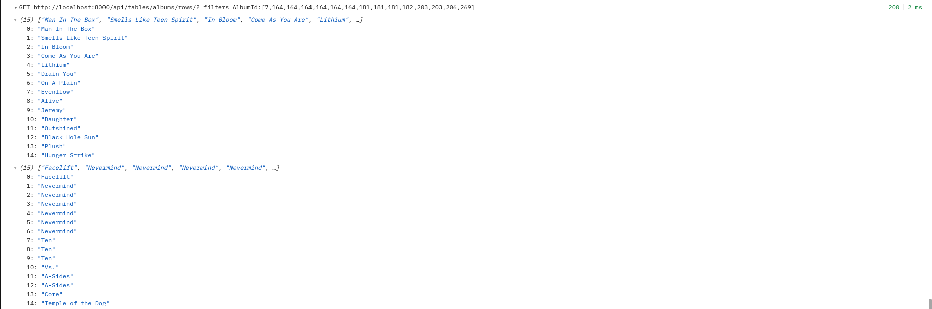  
  
we also collected artistids to a variable   
  
next --  
we used artist ids collected in previous rtesponse to Call artists table and get artists names   
  
URL: [http://localhost:8000/api/tables/artists/rows/?_filters=ArtistId:[5,110,110,110,110,110,110,118,118,118,118,132,132,134,204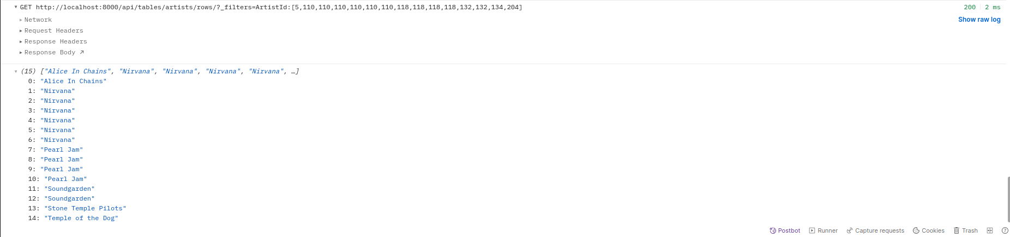](http://localhost:8000/api/tables/artists/rows/?_filters=ArtistId:[5,110,110,110,110,110,110,118,118,118,118,132,132,134,204)]  
  
  
{"data":[{"ArtistId":5,"Name":"Alice In Chains"},{"ArtistId":110,"Name":"Nirvana"},{"ArtistId":118,"Name":"Pearl Jam"},{"ArtistId":132,"Name":"Soundgarden"},{"ArtistId":134,"Name":"Stone Temple Pilots"},{"ArtistId":204,"Name":"Temple of the Dog"}],"total":6,"next":null,"previous":null}  
  
s

TO get the output in proper format wrote a fucntion to create and array of object with required data   
  
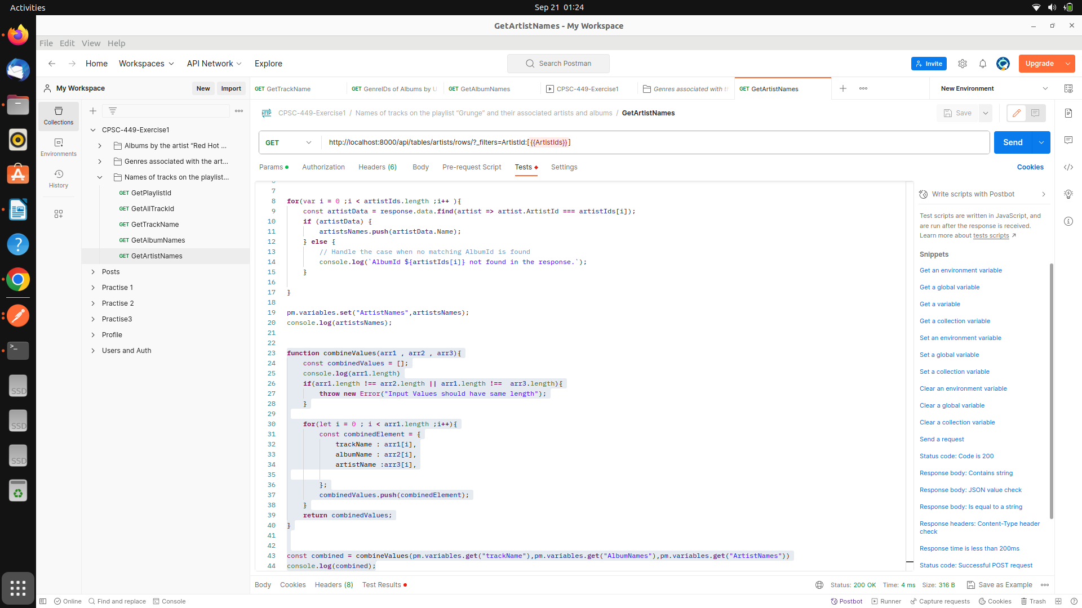

Output for query 3   
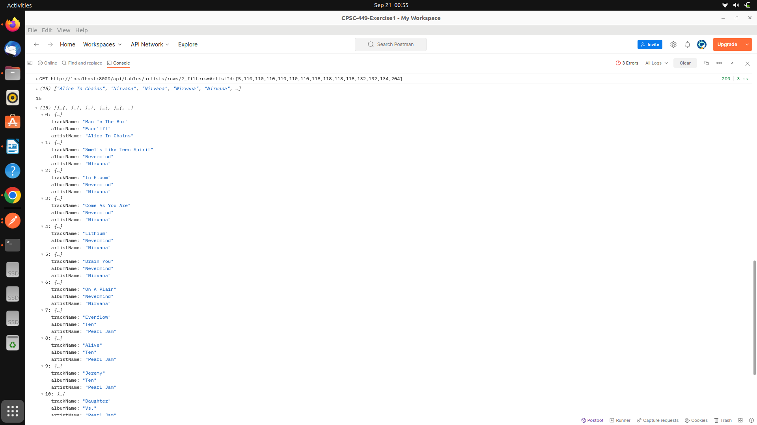

Making Api Call through python Graph QL   
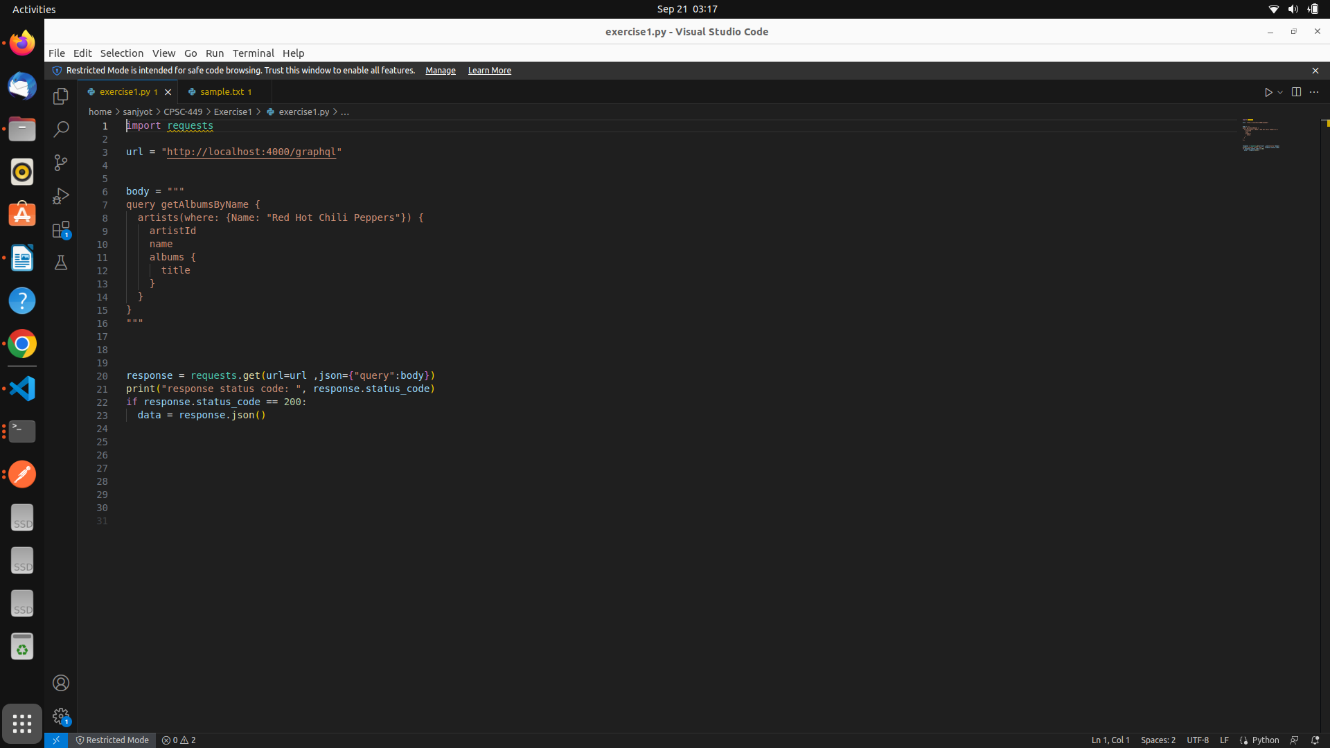  
  
imported request library and refered <https://requests.readthedocs.io/en/latest/> to send the request and run the query

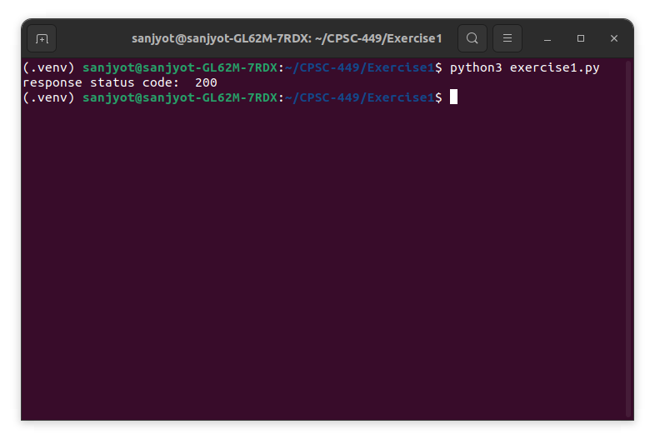  
  
since response code is 200 I can verify that api is working correctly and giving me the response   
  
  
---Next steps --  
I will make and array of query and make get calls and pass the query as a parameter to graphql API , also using if elseif I will run data maipulation on the response to get response for each query in desired format   
  
  
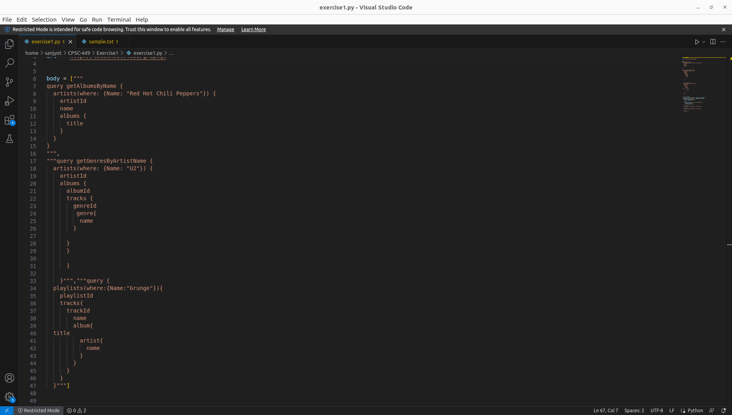

Added all the graphql queries wriiten earlier inside array , updated code using for loop

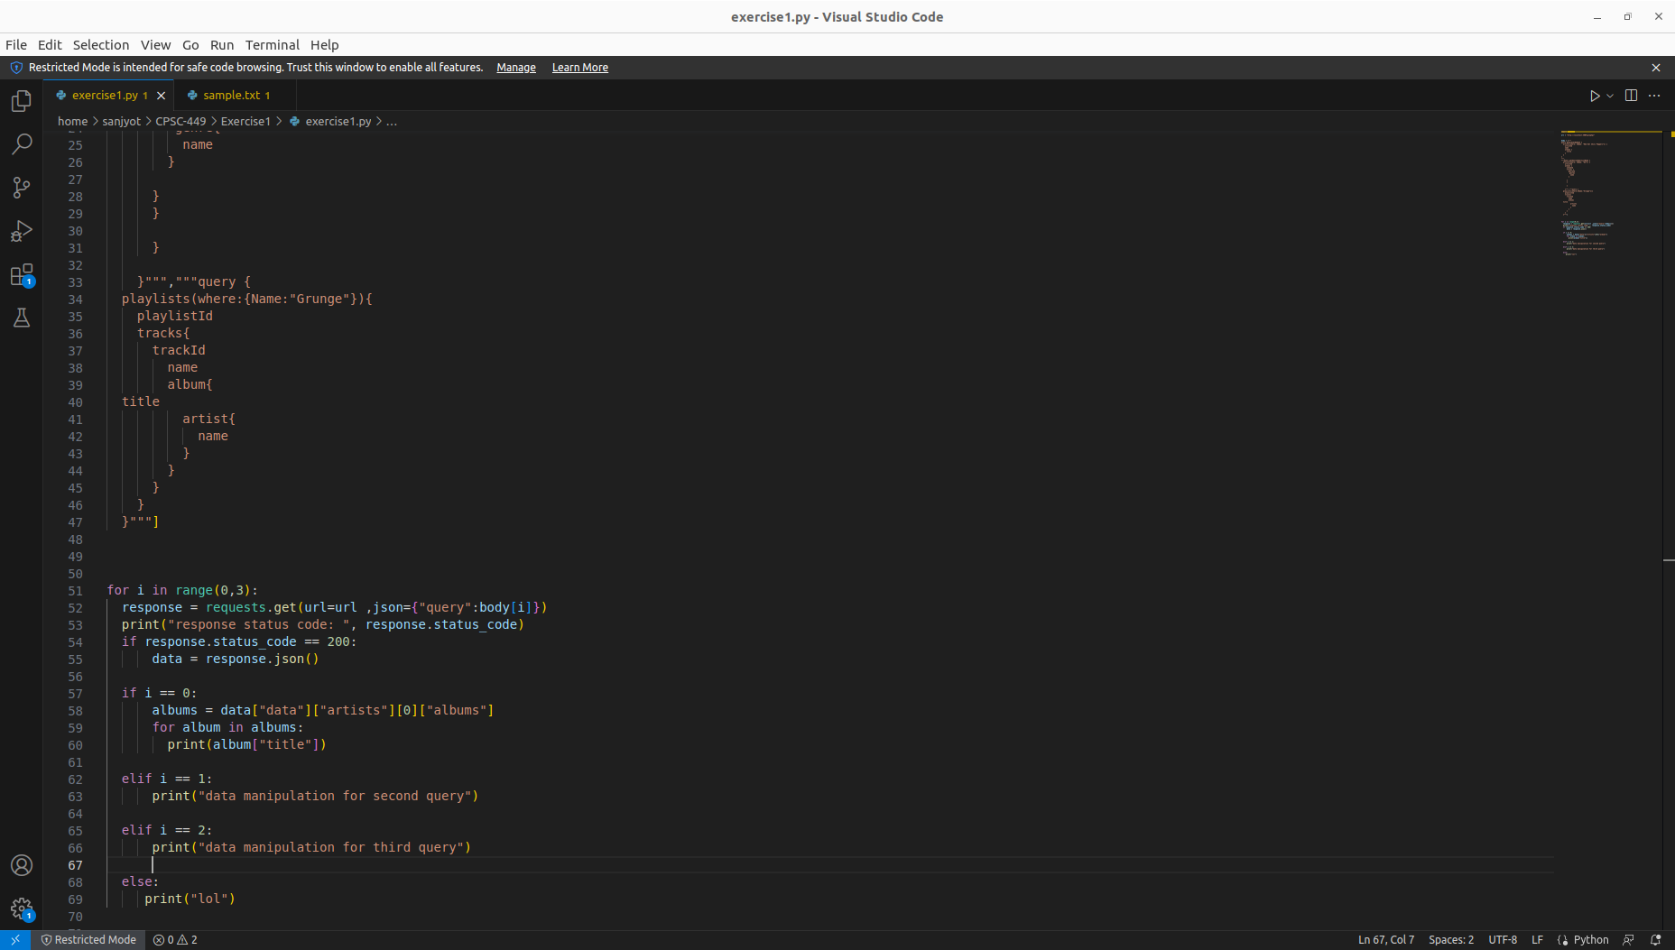

Running the Py file to get response for query 1   
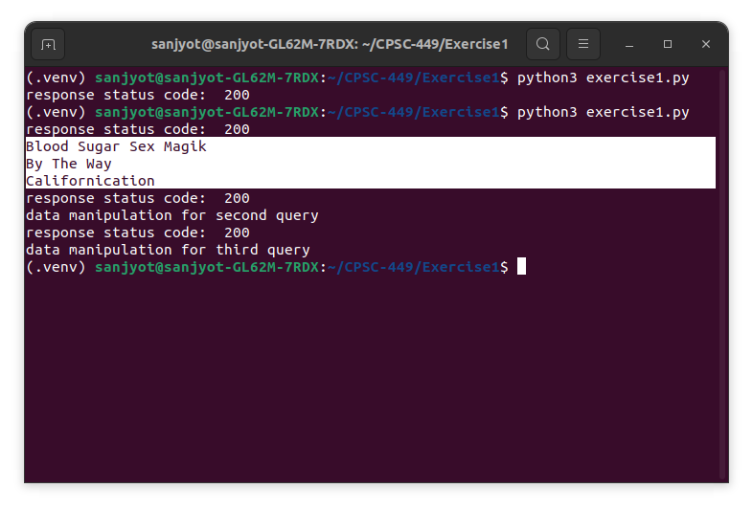

Updated the code to format the output in a neat way

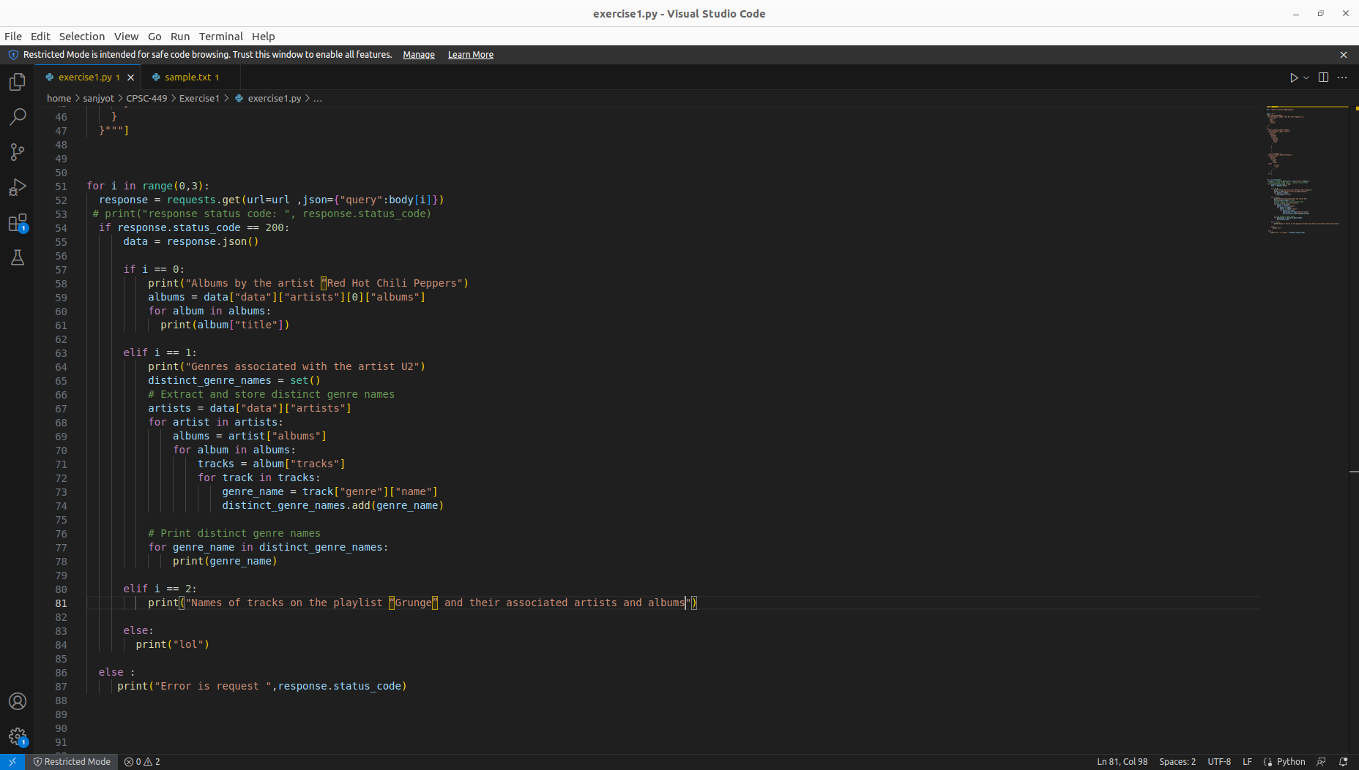

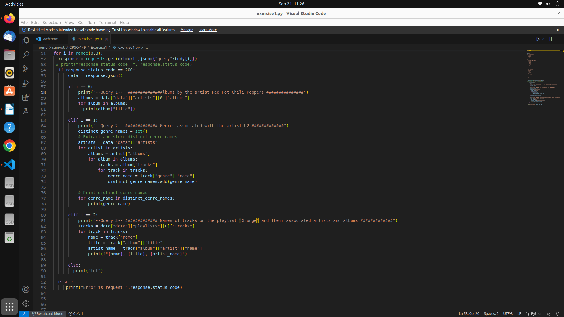

Output on running python file

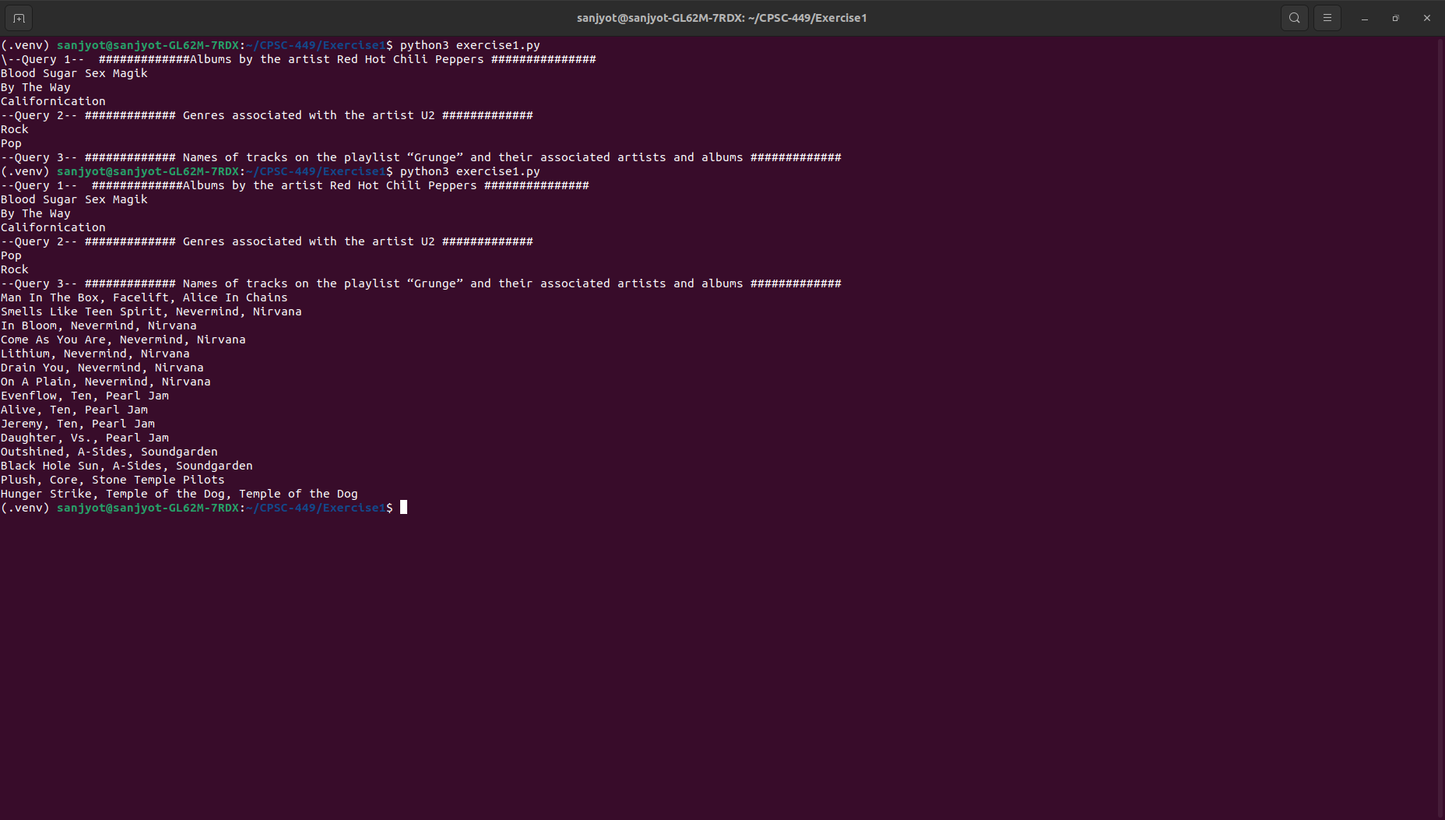  
  
  
  
Making API calls python Rest API suing Soul  
  
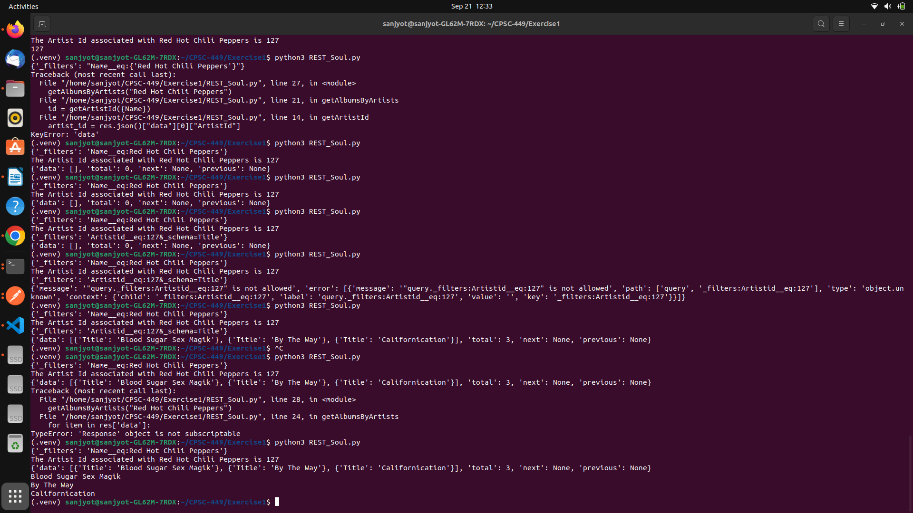s

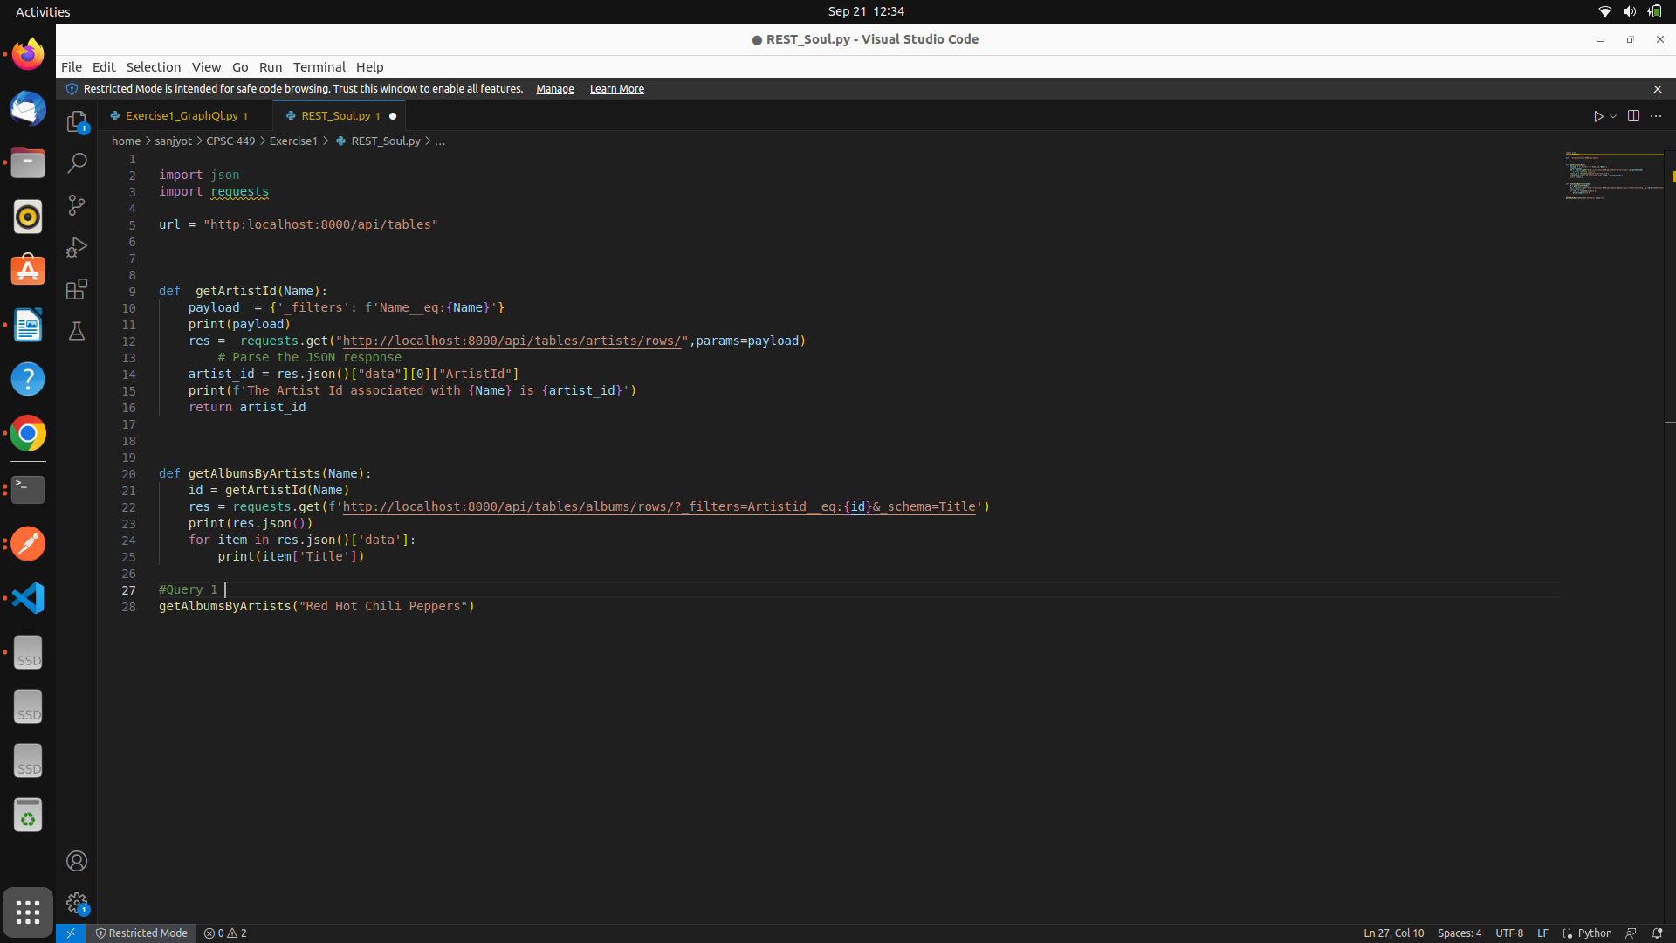s

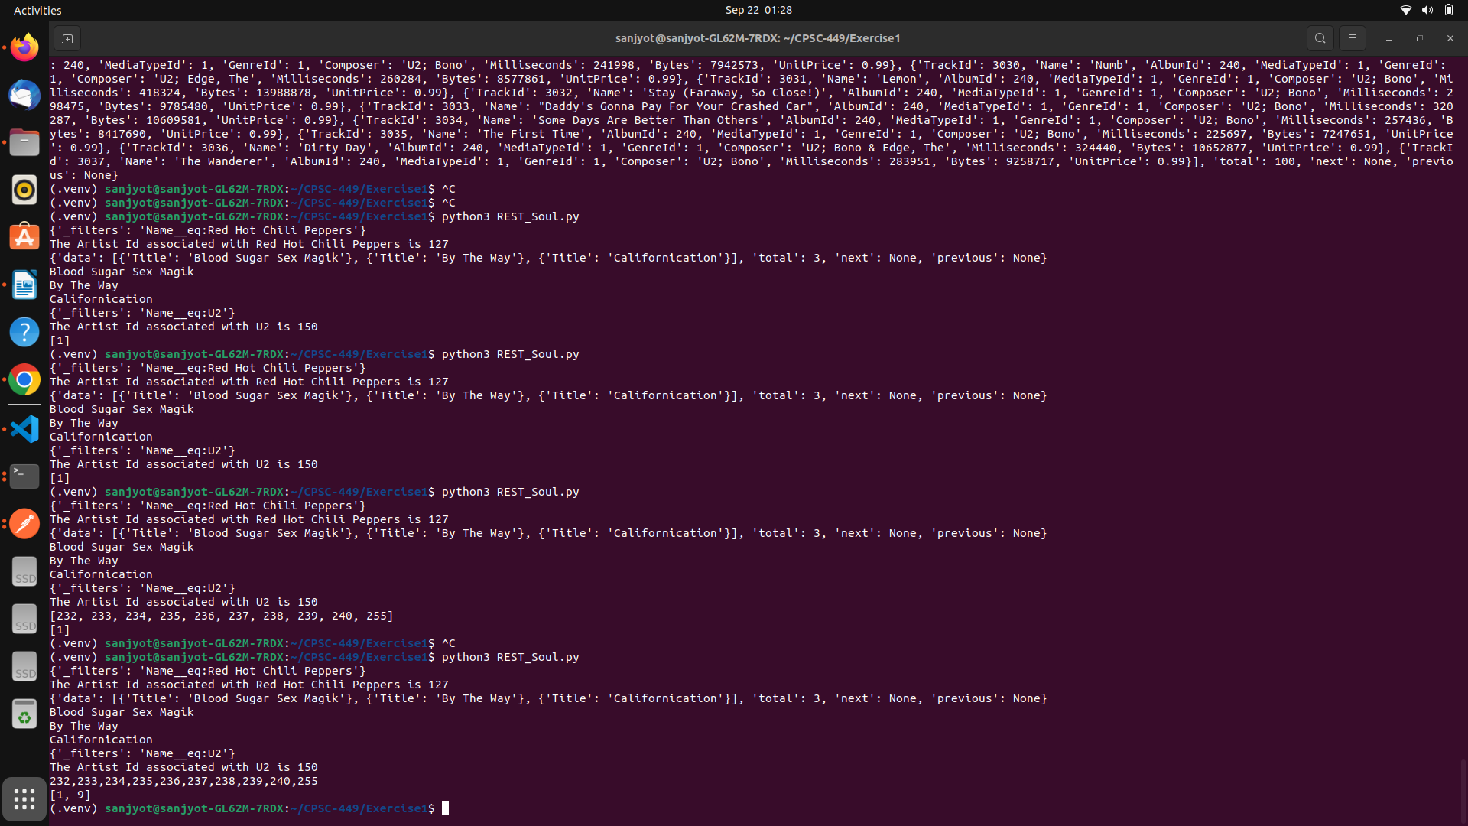Geeting incomplete Json ID , because there is space in URL after Album number wrote logic to pass without sopace   
  
s

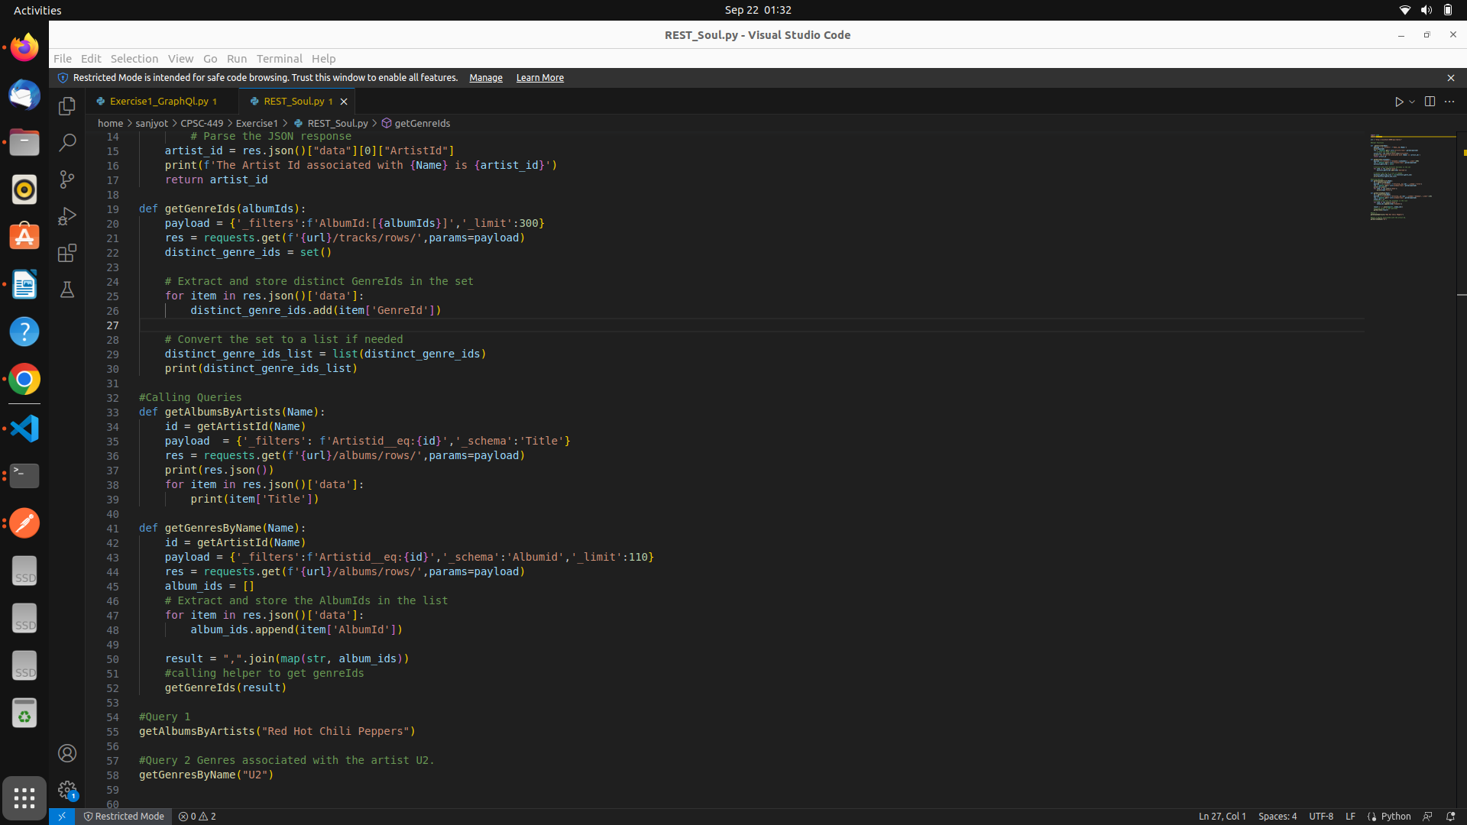  
After updating the code I am getting distint genre ids for U2 I can use those to get Genere Names

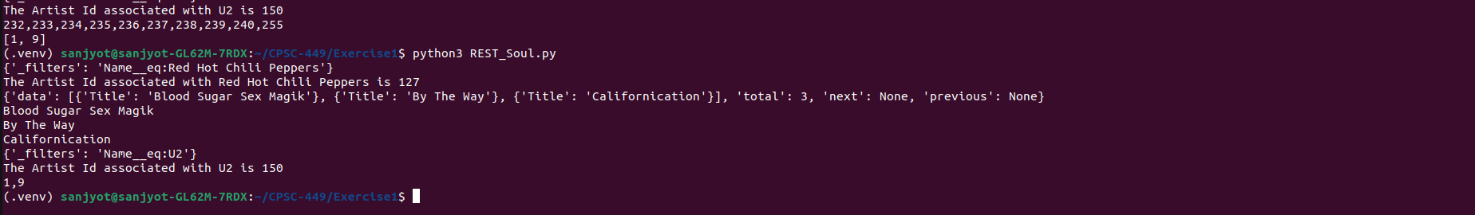s

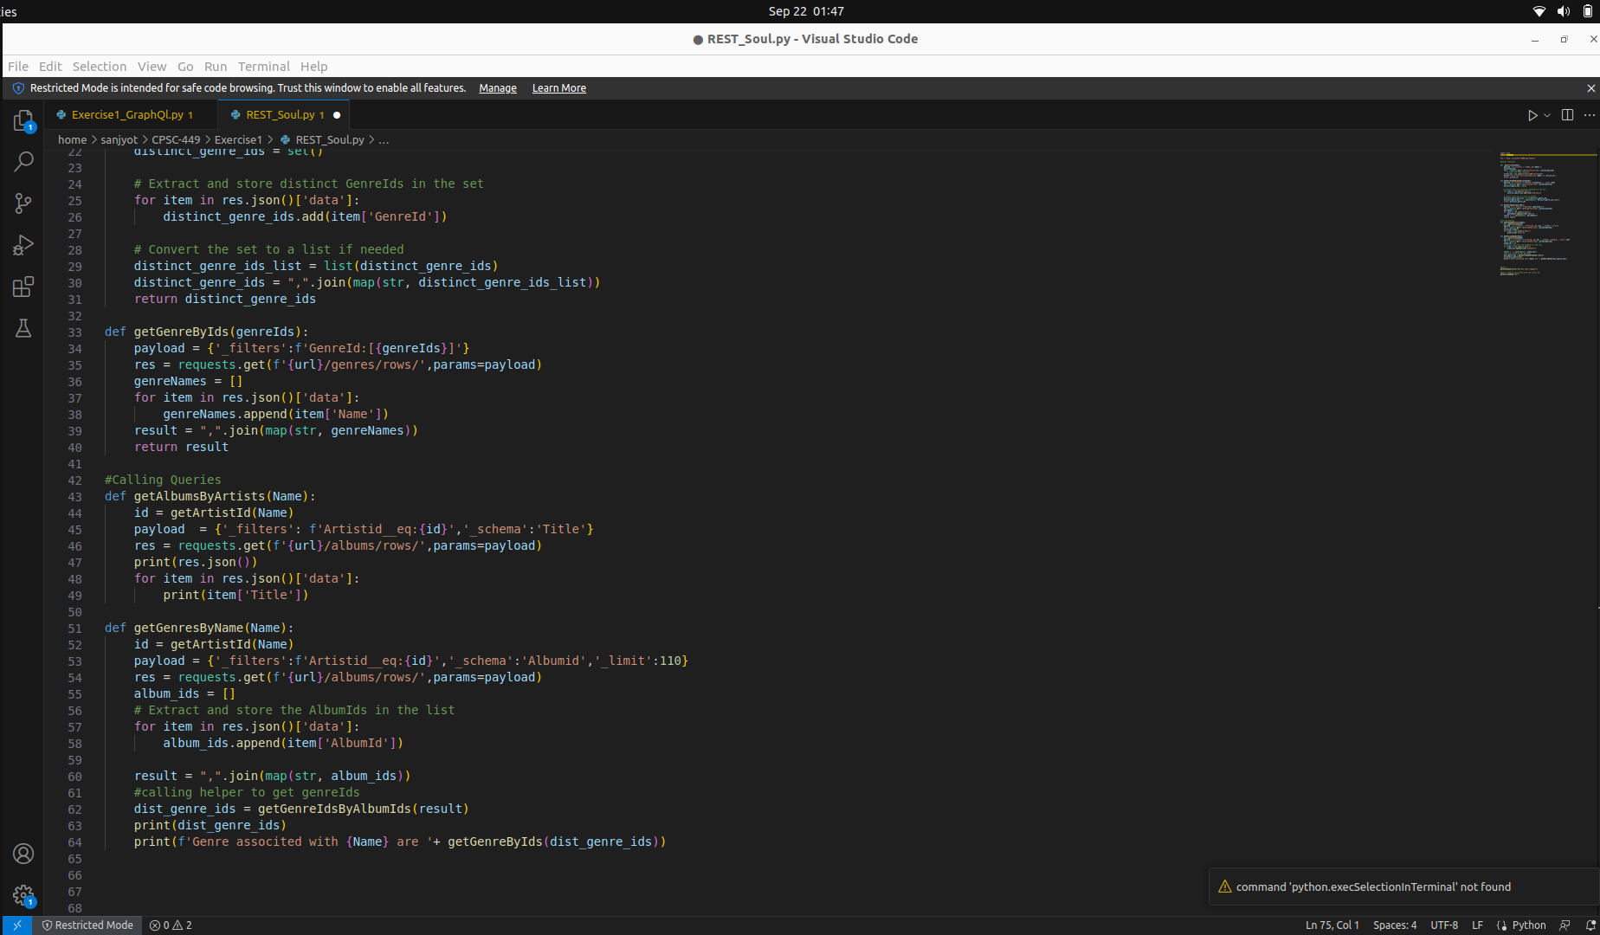s

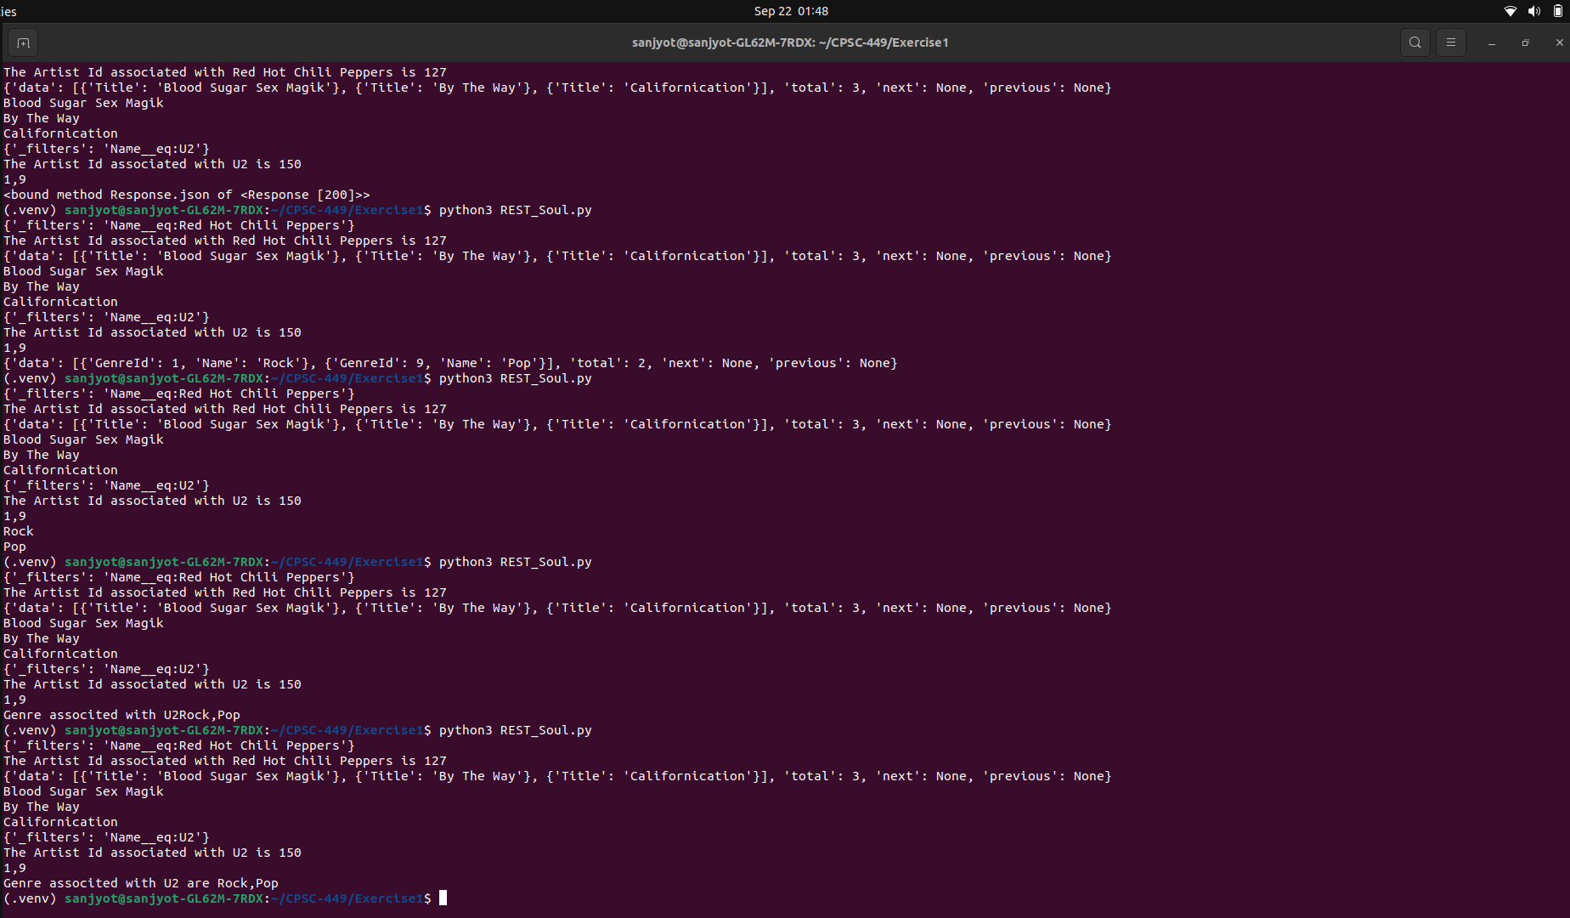s

Updating Query 3

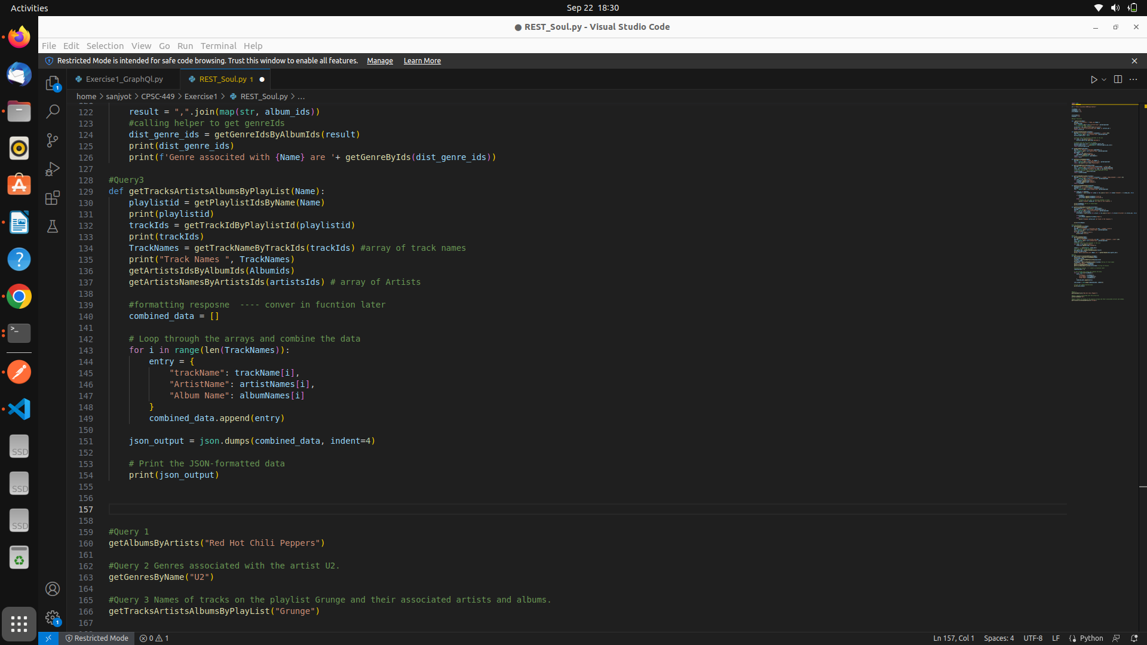s

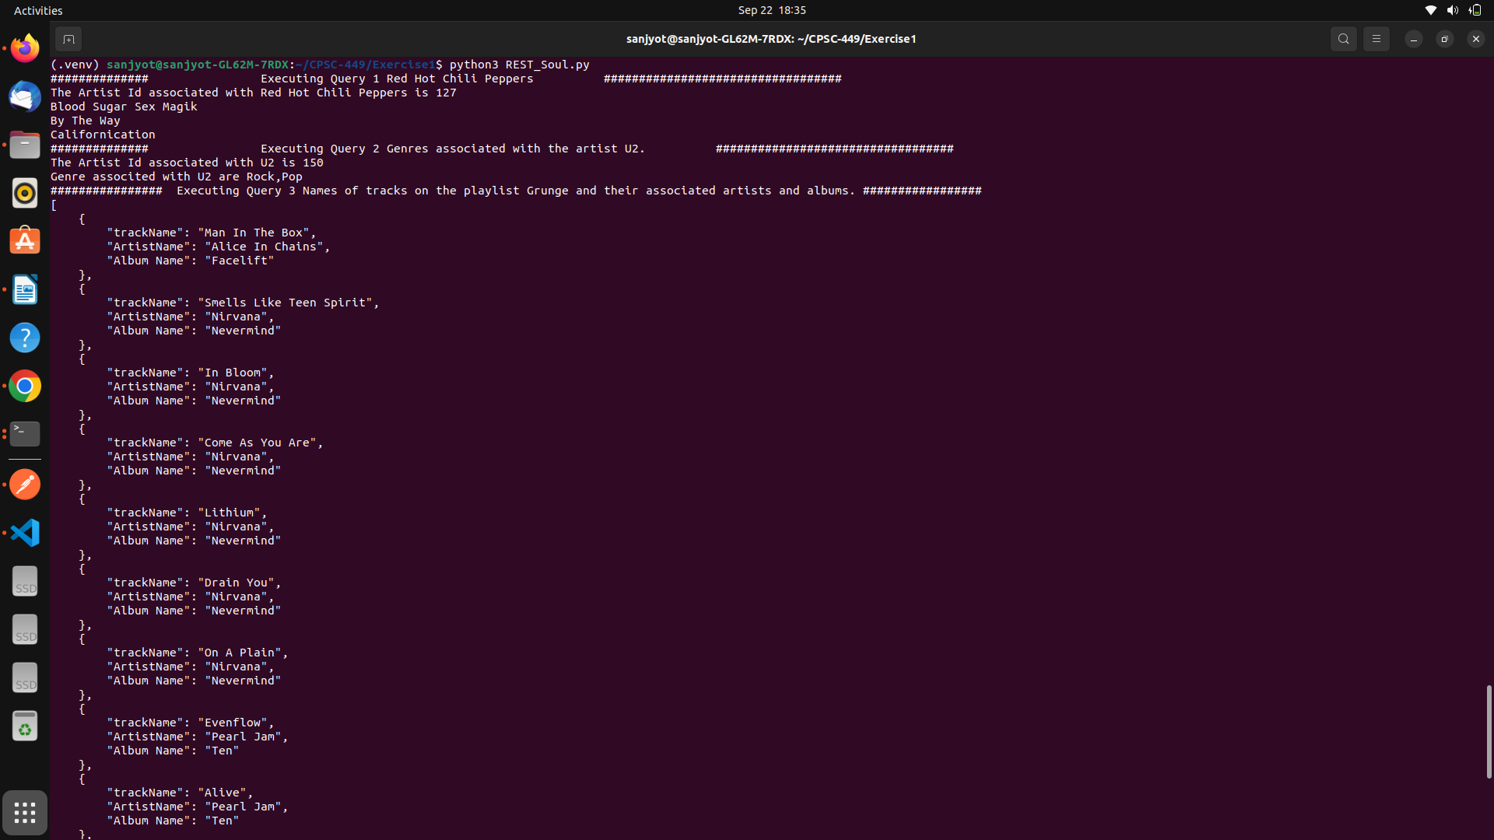Output

Python Code for Soul   
import json

import requests

url = "http://localhost:8000/api/tables/"

trackName = [];

albumNames = [];

artistNames = [];

artistsIds=[];

Albumids = [];

#Helper Functions

def getArtistId(Name):

payload = {'_filters': f'Name__eq:{Name}'}

res = requests.get(f'{url}/artists/rows/',params=payload)

artist_id = res.json()["data"][0]["ArtistId"]

print(f'The Artist Id associated with {Name} is {artist_id}')

return artist_id

def getGenreIdsByAlbumIds(albumIds):

payload = {'_filters':f'AlbumId:[{albumIds}]','_limit':300}

res = requests.get(f'{url}/tracks/rows/',params=payload)

distinct_genre_ids = set()

# Extract and store distinct GenreIds in the set

for item in res.json()['data']:

distinct_genre_ids.add(item['GenreId'])

# Convert the set to a list if needed

distinct_genre_ids_list = list(distinct_genre_ids)

distinct_genre_ids = ",".join(map(str, distinct_genre_ids_list))

return distinct_genre_ids

def getGenreByIds(genreIds):

payload = {'_filters':f'GenreId:[{genreIds}]'}

res = requests.get(f'{url}/genres/rows/',params=payload)

genreNames = []

for item in res.json()['data']:

genreNames.append(item['Name'])

result = ",".join(map(str, genreNames))

return result

def getPlaylistIdsByName(Name):

payload = {'_filters':f'Name__eq:{Name}'}

res = requests.get(f'{url}/playlists/rows/',params=payload)

return res.json()['data'][0]['PlaylistId']

def getTrackIdByPlaylistId(playlistId):

payload = {'_filters':f'PlaylistId:{playlistId}','_limit':20}

res = requests.get(f'{url}/playlist_track/rows/',params=payload)

track_ids = [str(item["TrackId"]) for item in res.json()["data"]]

# Join the TrackIds into a single comma-separated string

listOfTrackIds = ",".join(track_ids)

return listOfTrackIds

def getTrackNameByTrackIds(trackids):

payload = {'_filters':f'TrackId:[{trackids}]','_schema':'Name,AlbumId','_limit':25}

res = requests.get(f'{url}/tracks/rows/',params=payload)

for item in res.json()['data']:

trackName.append(item['Name'])

Albumids.append(item['AlbumId'])

return trackName

def getArtistsIdsByAlbumIds(Albumids):

AlbumIdslist = ",".join(map(str, Albumids))

payload = {'_filters':f'AlbumId:[{AlbumIdslist}]'}

res = requests.get(f'{url}/albums/rows/',params=payload)

for album_id in Albumids:

albumData = next((album for album in res.json()['data'] if album['AlbumId'] == album_id), None)

if albumData:

albumNames.append(albumData['Title'])

artistsIds.append(albumData['ArtistId'])

else:

# Handle the case when no matching AlbumId is found

print(f"AlbumId {album_id} not found in the response.")

#print(albumNames) #Array of Album Names

#print(artistsIds)

def getArtistsNamesByArtistsIds(artistsIds):

ArtistsIdsList = ",".join(map(str, artistsIds))

payload = {'_filters':f'ArtistId:[{ArtistsIdsList}]'}

res = requests.get(f'{url}/artists/rows/',params=payload)

for artist_id in artistsIds:

artistData = next((artist for artist in res.json()['data'] if artist['ArtistId'] == artist_id), None)

if artistData:

artistNames.append(artistData['Name'])

else:

print(f"AlbumId {artist_id} not found in the response.")

#print(artistNames)

#Calling Queries

def getAlbumsByArtists(Name):

print("############## Executing Query 1 Red Hot Chili Peppers ##################################")

id = getArtistId(Name)

payload = {'_filters': f'Artistid__eq:{id}','_schema':'Title'}

res = requests.get(f'{url}/albums/rows/',params=payload)

for item in res.json()['data']:

print(item['Title'])

#Query 2

def getGenresByName(Name):

print("############## Executing Query 2 Genres associated with the artist U2. ##################################")

id = getArtistId(Name)

payload = {'_filters':f'Artistid__eq:{id}','_schema':'Albumid','_limit':110}

res = requests.get(f'{url}/albums/rows/',params=payload)

album_ids = []

# Extract and store the AlbumIds in the list

for item in res.json()['data']:

album_ids.append(item['AlbumId'])

result = ",".join(map(str, album_ids))

#calling helper to get genreIds

dist_genre_ids = getGenreIdsByAlbumIds(result)

#print(dist_genre_ids)

print(f'Genre associted with {Name} are '+ getGenreByIds(dist_genre_ids))

#Query3

def getTracksArtistsAlbumsByPlayList(Name):

print("################ Executing Query 3 Names of tracks on the playlist Grunge and their associated artists and albums. #################")

playlistid = getPlaylistIdsByName(Name)

trackIds = getTrackIdByPlaylistId(playlistid)

TrackNames = getTrackNameByTrackIds(trackIds) #array of track names

getArtistsIdsByAlbumIds(Albumids)

getArtistsNamesByArtistsIds(artistsIds) # array of Artists

#formatting resposne ---- conver in fucntion later

combined_data = []

# Loop through the arrays and combine the data

for i in range(len(TrackNames)):

entry = {

"trackName": trackName[i],

"ArtistName": artistNames[i],

"Album Name": albumNames[i]

}

combined_data.append(entry)

json_output = json.dumps(combined_data, indent=4)

# Print the JSON-formatted data

print(json_output)

#Query 1

getAlbumsByArtists("Red Hot Chili Peppers")

#Query 2 Genres associated with the artist U2.

getGenresByName("U2")

#Query 3 Names of tracks on the playlist Grunge and their associated artists and albums.

getTracksArtistsAlbumsByPlayList("Grunge")

Response   
  
  
.venv) sanjyot@sanjyot-GL62M-7RDX:~/CPSC-449/Exercise1$ python3 REST_Soul.py

############## Executing Query 1 Red Hot Chili Peppers ##################################

The Artist Id associated with Red Hot Chili Peppers is 127

Blood Sugar Sex Magik

By The Way

Californication

############## Executing Query 2 Genres associated with the artist U2. ##################################

The Artist Id associated with U2 is 150

Genre associted with U2 are Rock,Pop

################ Executing Query 3 Names of tracks on the playlist Grunge and their associated artists and albums. #################

[

{

"trackName": "Man In The Box",

"ArtistName": "Alice In Chains",

"Album Name": "Facelift"

},

{

"trackName": "Smells Like Teen Spirit",

"ArtistName": "Nirvana",

"Album Name": "Nevermind"

},

{

"trackName": "In Bloom",

"ArtistName": "Nirvana",

"Album Name": "Nevermind"

},

{

"trackName": "Come As You Are",

"ArtistName": "Nirvana",

"Album Name": "Nevermind"

},

{

"trackName": "Lithium",

"ArtistName": "Nirvana",

"Album Name": "Nevermind"

},

{

"trackName": "Drain You",

"ArtistName": "Nirvana",

"Album Name": "Nevermind"

},

{

"trackName": "On A Plain",

"ArtistName": "Nirvana",

"Album Name": "Nevermind"

},

{

"trackName": "Evenflow",

"ArtistName": "Pearl Jam",

"Album Name": "Ten"

},

{

"trackName": "Alive",

"ArtistName": "Pearl Jam",

"Album Name": "Ten"

},

{

"trackName": "Jeremy",

"ArtistName": "Pearl Jam",

"Album Name": "Ten"

},

{

"trackName": "Daughter",

"ArtistName": "Pearl Jam",

"Album Name": "Vs."

},

{

"trackName": "Outshined",

"ArtistName": "Soundgarden",

"Album Name": "A-Sides"

},

{

"trackName": "Black Hole Sun",

"ArtistName": "Soundgarden",

"Album Name": "A-Sides"

},

{

"trackName": "Plush",

"ArtistName": "Stone Temple Pilots",

"Album Name": "Core"

},

{

"trackName": "Hunger Strike",

"ArtistName": "Temple of the Dog",

"Album Name": "Temple of the Dog"

}

]